

**Impact of homemade food for employees**

**A Sri Lankan Perspective**

Wekunagoda C.L（Reg. No.: MS18900514）

M.Sc. in IS

Supervisor:　Dr. Anuradha Jayakody

Dec 2019

**Department of Computer Systems Engineering**

**Faculty of Graduate Studies and Research**

**Sri Lanka Institute of Information Technology**

# **ACKNOWLEDGMENT**

I would like to thank everyone who encouraged me to finish my final year research successfully.

I would also take this an opportunity to thank my lecturer Dr. Anuradha Jayakody for giving me unconditional support throughout the research by sharing his knowledge, time and guidance.

I also thank my parents for being there with me in every thick and thin situation of my life.

# **ABSTRACT**

As the results of revolution of human life, people used to change their consumer patterns rapidly to make the complicated, stressful and busy life style to make it easy and simple. How people make it easy is buying fast food or ready-made food from a shop on the way home.

If we go back to before 21st century, majority of the office environment you get see men. So, women used to take care of the family by cooking, taking care of children etc… Considering the two eras; both men and women can be found equally in the office environment. Because of this reason women tempt to neglect the house holding work and they also adopt to modern fast food culture.

The fast foods are actually not good for health if you continuously eating them. These foods contain lot of sugar, oil, food colouring etc… These bad habits are causing serious health issues like diabetes, cholesterol, over weight issues, heart attack and cancers. The sellers are providing these popular types of foods for the society prioritizing the taste and not the side effects.

Making home- made foods are a huge challenge for most of the people with their busy schedules. It is also a challenge for preparing healthy foods because of the price, time and effort they have to put individually. So, this guides them to eat away from home and lead them to eat from outside.

The competition in the food industry is quite surprising. Shops are blooming everywhere speedily in Sri Lanka. Demand for fast food shops are still high even you see a rapid growth in the industry.

Society it-self appreciate the gatherings outside in a big comfortable, A/C hotel to dine in. This trend caused lot of health issues and made our life span a low.

Based on the collected data from my research; I found out that most of the people like to eat home -made foods than fast foods. Also, I have identified all the people are considering about their life and health. They all need a healthy life and they want to have a peaceful life without worries and sufferings.

The methods that I used to gather data for the research can be categorized as direct observation, interviews and questioners. This method helped me to gather more accurate and interesting data from the employees. Direct observation gives the best ideas on how the process going on as the researcher witness it by each aspect.

I have used SPSS tool to analyze data. In the research, I also found data by observing the situation also did interviews and questioners. I make sure myself that employees understand the questions and they also see this as a problem in day to day life, how they react etc.

The main problem is employees do not have enough time to prepare food at home. People are also looking for healthy foods. In a country like Sri Lanka there is a very less availability for homemade foods. This study will give a better solution for people who are looking for homemade foods. I also will implement a web based application which is helpful for the employees to order food who are looking for homemade foods. This application is user friendly where anyone can use it even without having a good computer knowledge.

**Table of Contents**

ACKNOWLEDGMENT 2

ABSTRACT 3

CHAPTER ONE – INTRODUCTION 11

1.1 Introduction 12

1.2 Problem Identification 13

1.3 Problem justification 15

1.4 Research Problem 16

1.6. Main Objective 17

1.7 Sub Objectives 17

1.8 Significance of the study 18

1.9 Limitations of the study 18

1.10 Overview of the thesis 18

CHAPTER TWO – LITERATURE REVIEWE 19

2.1) Introduction 19

2.2 Fast food 20

2.3 Fast-food preferences and consumer patterns 20

2.4 Homemade food as a healthy lifestyle 21

2.5 Demand for Healthy Meal 21

2.6 What do employees expect from healthy meals? 22

2.7 Food Preferences among people and consumption patterns 22

2.8 Fast food industry in Sri Lanka 22

2.9 Variables that affect food consumption 23

2.10 Healthy eating habits among employees 23

2.11 What is a healthful diet and how does it impact to the research? 24

2.12 Factors in Food Preference 24

2.12.1 Convenience 25

2.12.2 Availability 25

2.12.3 Natural content 26

2.12.4 Weight benefits 26

2.12.5 Sensory appeal 27

2.12.6 Price 27

2.12.7 Health concern 28

2.12.8 Organic concern 28

2.13 Food Preference 29

2.14 Current and similar systems 30

2.15 User Experience and Design 30

2.15 Mobile responsive 30

2.16 Localization 31

2.17 Optimized performance 31

2.18 Comparing references to the web application solution 32

2.19 Importance of using mobile platform supported applications 33

2.21 Benefits of using mobile responsive design 34

2.21.1 Support multiple devices 34

2.21.2 One site development is enough 35

2.21.3 Optimized the search engine 35

2.21.4 Scalability 35

2.22 Summery 36

CHAPTER THREE – METHODOLOGY 37

3.1 Introduction 37

3.2 Research Design 37

3.3 Research Approach 37

3.3.1 Deductive Approach 38

3.3.2 Inductive Approach 38

3.4 Sample Study 39

3.5 Sample size 39

3.6 Data Collection Methods 39

3.7 Data examination 41

3.8) Conceptual framework 42

3.9 Research Hypothesis 43

3.10 Operationalization 43

3.10.1 Operationalization of Convenience 44

3.10.2 Operationalization of Availability 44

3.10.3 Operationalization of Natural content 45

3.10.4 Operationalization of Weight benefits 46

3.10.5 Operationalization of Sensory appeal 47

3.10.6 Operationalization of Price 48

3.10.7 Operationalization of Health concern 49

3.10.8 Operationalization of Organic concern 50

3.10.9 Operationalization of Food Preference 51

3.11 Independent Variables 52

3.12 Dependent Variable 52

3.13 summary 53

CHAPTER FOUR – DATA PRESENTATION 54

4.1 Introduction 54

4.2 Demographic factors analysis of sample. 54

4.2.1 Age configuration of the study 55

4.2.3 Level of Occupation 55

4.3 Fast foods liked by sample 56

4.4 Homemade food liked by sample 56

4.5 Reliability and validity 57

4.6 Correlations between Convenience and Availability 58

4.7 Impact on Convenience on Food preference 59

4.7.1 Correlations of Convenience and Food Preference 59

4.7.2 Regression analysis of Convenience and Food Preference 60

4.7.3 Significance test of Convenience and Food Preference 61

4.8 Correlations of Availability and Food Preference 61

4.8.1 Regression analysis between Availability and Food Preference 62

4.8.2 Significance test of Availability and Food Preference 63

4.9 Correlations of Natural content and Food Preference 64

4.9.1 Regression analysis between Natural Content and Food Preference 64

4.9.2 Significance test of Natural Content and Food Preference 65

4.10 Correlations of Weight benefits and Food Preference 66

4.10.1 Regression analysis between Weight benefits and Food Preference 67

4.10.2 Significance test of Weight benefits and Food Preference 68

4.11 Correlations of Sensory appeal and Food Preference 68

4.11.1) Regression analysis between Sensory appeal and Food Preference 69

4.11.2 Significance test of Sensory appeal and Food Preference 70

4.12 Correlations of Price and Food Preference 71

4.12.1 Regression analysis between Price and Food Preference 71

4.12.2 Significance test of Price and Food Preference 72

4.13 Correlations of Health Concern and Food Preference 73

4.13.1 Regression analysis between Health Concern and Food Preference 73

4.13.2 Significance test of Health Concern and Food Preference 74

4.14 Correlations of Organic Concern and Food Preference 75

4.14.1 Regression analysis between Organic Concern and Food Preference 75

4.14.2 Significance test of He Organic Concern and Food Preference 76

4.15 Summery 77

CHAPTER FIVE - SYSTEM DESIGN 78

5.1 Introduction 78

5.2 Design Methodology 78

5.3 Architecture of the System 79

5.4 Design 80

5.4.1 Entity Relation Diagram 80

5.4.2 Sequence diagram 81

5.6 Screen Designs of the Application 86

5.6.1 Sign up page for Seller 86

5.6.2 Login page for Seller 87

5.6.4 Seller Food menu 88

5.6.9 Buyer Login Page 90

5.6.10) Buyer Home page 91

5.6.11 Buyer Menu page 92

5.7 Debugging/Testing 92

5.7.2 Link testing 97

5.8 Evaluation of the system 98

5.9 Summery 99

6.1 Introduction 100

6.2 Recommendations 108

6.3 Limitations and Constraints 109

6.4 Solution 109

6.5 Further work 109

7. REFERENCES 110

APPENDIX 112

Questionnaires 112

Screen Designs of the Application 117

Sign up page for Seller 117

Login page for Seller 118

Seller Home page 118

Seller Food menu 119

Seller – Add new food page 119

Seller – Edit Food Detail page 120

Seller – Delete Food Page 120

Buyer Sign up Page 121

Buyer Login Page 121

Buyer Home page 122

Buyer Menu page 123

Buyer Food details page 123

Buyer ordering a food page 124

Buyer – Successful order page 124

Buyer Order details page 125

Buyer details page 125

Application contact details page 126

Summary of the collected data 127

**List of Tables**

**Table 3.1: Operationalization of Convenience** 44

**Table 3.2: Operationalization of Availability** 44

**Table 3.3: Operationalization of Natural content** 45

**Table 3.4: Operationalization of Weight benefits** 46

**Table 3.5: Operationalization of Sensory appeal** 47

**Table 3.6: Operationalization of Price** 48

**Table 3.7: Operationalization of Health concern** 48

**Table3.8: Operationalization of Organic concern** 49

**Table 3.9: Operationalization of Food Preference** 50

**Table 4.10: Demographic factors analysis of sample.** 53

**Table 4.11: Age configuration of the study** 54

**Table 4.12: Level of Occupation** 54

**Table 4.13: Fast foods liked by sample** 55

**Table 4.14: Homemade food liked by sample** 55

**Table 4.15: Reliability and validity** 56

**Table 4.16: Correlations between Convenience and Availability** 57

**Table 4.17: Correlations of Convenience and Food Preference** 58

**Table 4.18: Model Summary** 59

**Table 4.19: ANOVA** 59

**Table 4.20: Coefficients** 59

**Table 4.21: Correlations of Availability and Food Preference** 60

**Table 4.22: Model Summary** 61

**Table 4.23: ANOVA** 61

**Table 4.24: Coefficient** 62

**Table 4.25: Correlations of Natural content and Food Preference** 63

**Table 4. 26: Model Summary** 63

**Table 4.27: ANOVA** 64

**Table 4.28: Coefficient** 64

**Table 4.29: Correlations of Weight benefits and Food Preference** 65

**Table 4.30: Model Summary** 66

**Table 4.31: ANOVA** 66

**Table 4.32: Coefficients** 66

**Table 4.33: Correlations of Sensory appeal and Food Preference** 67

**Table 4.34: Model Summary** 68

**Table 4.35: ANOVA** 68

**Table 4.36: Coefficients** 69

**Table 4.37: Correlations of Price and Food Preference** 70

**Table 4.38: Model Summary** 70

**Table 4.39: ANOVA** 71

**Table 4.40: Coefficients** 71

**Table 4. 41: Correlations of Health Concern and Food Preference** 72

**Table 4.42: Model Summary** 72

**Table 4.43: ANOVA** 73

Table 4.44: Coefficient 73

**Table 4.45: Correlations of Organic Concern and Food Preference** 74

**Table 4.46: Model Summary** 74

**Table 4.47: ANOVA** 75

**Table 4.48: Coefficient** 75

**List of Figures**

**Figure 2.1: Percentage of digital hours spent globally (smartinsights, 2017)** 34

**Figure 2.2: Top website’s mobile adaption survey (mobiforge, 2017)** 34

**Figure 3.1: Deductive Approach………………………………………………………………..………….……………….………….**38

**Figure 3.2: Inductive Approach………………………….……………………………………….…………………………………….** 38 **Figure 3.3: Conceptualframework……….…….…………………………………………….………………………….………......**41

**Figure 5.1: Three tier architecture diagram……………………….……………………………………………………………..** 77 **Figure 5.2: ER Diagram…………………………………………………….………………………………………………………….……** 78 **Figure 5.3: Sequence diagram…………………………..……………………………………………………………………………...**79 **Figure 5.4: Flowchart……………………………………………….……………………………………………………………………….** 81 **Figure 5.5: Use Case Diagram……………………………………………………………………………………………………………** 83 **Figure 5.6: Sign up page for Seller…………………………..……………………………………………………………..…………**84 **Figure 5.7: Login page for Seller……………………………………………….……………………………………………………….**85

**Figure 5.8: Seller Home page…………………………………………………………………………………………………………….**86 **Figure 5.9: Seller Food menu………………………………………………………..……………………………………………….…** 87 **Figure 5.13: Buyer Sign up Page………………………………………………………………………………………………………..**88 **Figure 2.14: Buyer Login Page…………………………………………………………………………………………………………..**89 **Figure 5.15: Buyer Home page………………………………………………………………………………………………………….**90 **Figure 5.16: Buyer Menu page……………………………………………………………………………..………………………….** 91

# **CHAPTER ONE – INTRODUCTION**

## **1.1 Introduction**

As the results of revolution of human life, people used to change their consumer patterns rapidly to make the complicated, stressful and busy life style to make it easy and simple. How people make it easy is buying fast food or ready-made food from a shop on the way home.

If we go back to before 21st century, majority of the office environment you get see men. So, women used to take care of the family by cooking, taking care of children etc… Considering the two eras; both men and women can be found equally in the office environment. Because of this reason women tempt to neglect the house holding work and they also adopt to modern fast food culture.

The fast foods are actually not good for health if you continuously eating them. These foods contain lot of sugar, oil, food colouring etc… These bad habits are causing serious health issues like diabetes, cholesterol, over weight issues, heart attack and cancers. The sellers are providing these popular types of foods for the society prioritizing the taste and not the side effects.

Making home- made foods are a huge challenge for most of the people with their busy schedules. It is also a challenge for preparing healthy foods because of the price, time and effort they have to put individually. So, this guides them to eat away from home and lead them to eat from outside.

The competition in the food industry is quite surprising. Shops are blooming everywhere speedily in Sri Lanka. Demand for fast food shops are still high even you see a rapid growth in the industry.

Society it-self appreciate the gatherings outside in a big comfortable, A/C hotel to dine in. This trend caused lot of health issues and made our life span a low.

People who are in Colombo are mostly here to do jobs. They are tired and lazy to cook food because of those reasons. So without an intention they used to tempt to find food from popular places like KFC, Mc Donalds, Burger King, Dinemore, Pizza Hut, Dominos and etc. So, these people realized that buying fast foods are easier than cooking homemade foods.

Food safety in delivering and food tasty in fast foods are the main factors that has been found in the recent studies. The second priority is food quality, freshness and cleanness in fast food industry. People are easting outside from home because of the easiness. Fast food industry is growing fast in the world. So, people only give their priority to easiness and availability. Due to life style changes people always choose the convenience method [1].

Today people mainly don’t have time because everything in today’s life is based on money. People are mostly trying to work hard for a bigger salary, they are having a stressful life. Because of this reason they tempt to go out and spend the little time they have is with their family members. [2]

After employees realize fast food has health issues nearly one of five skip the breakfast. Healthy eating behavior is more important for healthy growth. [3]

Some studies have shown that organic foods are kind of healthy foods and environmental friendly. People are preferred healthier life style based on the organic diet. Despite the fact that consumer research can provide us with valuable information on the lifestyle of a young adult based on an organic diet, it is also necessary to look for a person who seeks a psychological meaning in the depth of life experience to provide an alternative to consumer point of view [4]

## **1.2 Problem Identification**

As the results of survey study, overweight and obesity has increased rapidly among the people who are doing jobs in Sri Lanka. So, these problems have occurred because of the unhealthy living life style. People need to follow a good healthy diet. Otherwise they are going to face a big problem in future. Recent studies have shown that the living period of a person in Sri Lanka is between 60 to 70 years (men) and 65 to 75 years (women). Reason of this issue is the unhealthy living life style and they do not eat hygienic and homemade foods.

An unhealthy diet is caused to heart problems, high blood pressure, high blood sugar, cancer and etc. Especially people who are doing jobs, they do not have enough time to cook hygienic foods. Therefore, they always prefer to have fast foods than homemade foods. They think that, it is useless to spent time for cooking and easy to buy fast foods. People are lazy to cook especially women who are doing jobs. This is happened because of their busy schedule. This unhealthy food pattern leads to serious health issues because of this reason.

Most of the people like to eat homemade foods. They do not have time to spend for cooking. Recent study has shown that there is a huge demand for homemade foods in the society. If people eat hygienic and homemade foods, their consumer of food will completely change and they will prevent from the serious illnesses. Everyone knows that fast foods are not good for health. It creates unknown illnesses as well. To prevent from these illnesses people to need to change their eating pattern of foods immediately.

Due to changes in life style, people especially women are more like to eat fast foods, junk foods than eating home-made foods. Women don’t have time for cooking. So, their families are always chosen to buy fast foods. They know that eating fast foods are impacted to unhealthier life style. Because of their busy schedule they don’t have time to cook healthy meals. In Sri Lanka, most of the people are coming to the Colombo to do jobs. These people are always deciding to eat fast foods from popular meal shops like KFC, Mc Donalds, Burger King, Dinemore, Pizza Hut, Dominos etc. So, these people have chosen that buying fast foods are easier than cooking homemade foods.

There are chefs who are willing to sell their home-made foods menus to the people. They do not have financial support to do that. If there is a way to sell their foods via online web based application they can sell their home-made foods quickly without a big effort. These chefs are more like to sell their products through online application. So, they can earn extra money also.

In current situation, there is less access for homemade foods when people need. When there is a demand for homemade foods, chefs are ready to sell organic foods because they are concern about society health condition. Therefore, people who are ready to pay more for healthy meals. Today fast food industry is getting a huge profit. They only consider about the selling rate. They do not consider about the human life. So, this trend need to be stopped as soon as possible. Otherwise people are getting sick day by day.

## **1.3 Problem justification**

In the study of homemade foods impact of employees, there are specific areas which are uncovered that provide more the customer’s food preference. Service providers always need to give their best products to the people to gain good customer satisfactions. By examine the problem that is related to this study, people need to avoid by having fast foods. They should be realized that unhealthy foods are not good to their life. People will have serious health issues by eating these types of unhealthy foods. If people know their heath condition is good according to their age which means they follow a good heath diet.

By observing the relationship between people and their food preference will help to identify which food that they need to eat according to their health condition and it helps to identify the which taste of foods people like to eat the most or still they like to eat more fast foods with their health issues. Country needs to give the support to the chefs (who are preparing homemade foods) who are willing to provide the service to the customers. By analyzing these issues will help to make the healthy products and provide the real service to the customers what they really expect. If chefs are like to sell their healthy meals to the customers, they will win their customer’s attraction and can gain more profits and they will be stable financially as well.

As we know that Sri Lanka is a developing country by technology, we can start trying to change from the Sri Lankan community and make them healthy in order to keep one step ahead. As for my researching data, there are home chefs who like to provide their service to the customers within their cities. They do not have financial assets to do that. From creating a web application; chefs can mention their home-made foods menu in the system and customers can order which food they need. By having web based application, both parties’ issues will solve.

By analyzing the impact of homemade foods to the employees will help by buying from these homemade food available places considering their healthy.

## **1.4 Research Problem**

In the present world, people’s living period is between ages 60-70. When you look in to the past generation, their living period is more than 80 years. So, there is a big different between immediate early generation and present generation. Past generation was lived more because they ate homemade and hygienic foods. The present generation, most people are used to have fast or junk foods.

A study of McKinsey and Company has shown that obesity is the major problem in present generation and this has occurred because of the eating behavior of fast foods. As an implication, obesity is creating the most expensive illness in the healthcare and government. In a developing country like Sri Lanka we are facing with this problem. Especially women who are doing jobs, they do not have enough time to prepare homemade foods. Therefore, their families are used to eat outside foods like burgers, kottu, submarine, fried rice etc.

Overweighting and obesity is the major problem in Sri Lankans people. Because of their busy schedule they do not have enough time for cooking. This problem is increasing highly daily. Solution for this problem is to eat healthy meals. People need to eat the healthy and homemade foods. In software based companies, these employees are working till late night. What they are doing is they order foods from popular shops and eat. If homemade foods are available in the shops, they will order these types of foods. The current situation there is no homemade foods in every city.

As I mentioned earlier, there are some home chefs who like to sell their tastiest homemade foods to the people in their city. These chefs are like to sell these types of homemade foods as their jobs. They do not have financial assets to do that. From creating a web application, chefs can mention their home-made foods menu in the system and customers can order which food they need. By having a web based application, both parties’ issues will solve. The researcher will develop a web application and this web application will give better solution for the identified problems of those parties.

This study examines eight motivational factors regarding the food preference. The factors are Convenience, Availability, Natural Content, Weight benefits, Sensory appeal, Price, Health concern, Organic concern. The research will clearly show how these factors are contribute the consumers’ food preference.

**1.5 Research questions**

In the current world people are used to eat fast foods than homemade foods. As I discussed earlier, eating fast foods leads to create serious health issues.

* How far is it possible for customers, in particular to find and buy healthy homemade food prepared by aspiring home chefs within the commutable distance?
* How the home does homemade foods impact to the employees’ life style?

## **1.6. Main Objective**

* The main object is to identify whether there is a real demand among consumers for healthy foods who are preparing by home chefs.

## **1.7 Sub Objectives**

* To create a marketplace where both customer and services providers can communicate their needs without going through inconvenient processes.
* To find and buy healthy home- cooked meals in their cities.
* To improve communication channels between service providers and the customer.
* To identify whether an unoccupied opportunity in the market place for healthy food.
* To identify what made the consumers away from healthy meal.

## **1.8 Significance of the study**

This research will be limited to the employees. This research will discuss how to impact the home-made foods for employees in the Colombo area. This research is only covered the employees who are living in the Colombo area. Even this research narrows down to the fast food and homemade food industry, the findings of this study will help to expand the consumer pattern of foods.

## 

## **1.9 Limitations of the study**

Since this was done only Employees in Colombo area also the application developed only Colombo city. In future, this application can be enhanced and all the people of Sri Lanka can be used this application. The application supports all the browsers also it can be used with any mobile device which supports HTML5 and JavaScript.

## **1.10 Overview of the thesis**

In this study, researcher has discussed the main problems that employees are facing when they make decision about food preference. The purpose behind the report, outlining problems investigated & any info necessary for an overview. The researcher has proposed the solution for the identified problems. This solution will create a marketplace where both customer and service providers can communicate their need without going through inconvenient processes.

# **CHAPTER TWO – LITERATURE REVIEWE**

## **2.1) Introduction**

A literature review is a structure which summarizes the information that is related to the research questions by mentioning the secondary sources like analysis and evaluation of the original information. The creation of literature review supports to gain the knowledge about the research questions and was help me to understand the situations further in depth to develop the framework of the research to continue the methodology of the research. It is important to have more information that is related to the research questions and also it supports to recognize the key areas of the research which I am going to address during the research.

Also, it let others to assess, compare and contrast the facts which they found from the related sources and present the research in a logical manner. Thus, a literature review benefits in so many ways to the researcher to avoid inadequate attempts. First of all, it aids to avoid reinvention which saves the time and resources by providing enough information to choose and conduct a successful research. This research chapter identifies where the previous researchers have stopped and majored so it allows expanding the knowledge of myself about the referring area of the research question.

Therefore, it is obvious that to analyze other software applications to build and implement an effective, efficient, and accurate system with exact user requirements to earn higher customer satisfaction. The key scenario which the I have concerned for the purpose of this research has mentioned under the research question and research problem and justification in the previous chapter.

## **2.2 Fast food**

Fast foods are preparing quickly, price is reasonable and available anytime than homemade food when people need. It has mentioned that fast foods are the fastest food type in the world and it also can prepare quickly, sensible prices and available for any time than homemade foods. Fast foods can easily and quickly prepare also people who are buying, they are only considering about how convenient it is and the availability of the food.

## **2.3 Fast-food preferences and consumer patterns**

Since the last decade, consumer pattern of people has been changed radically. This eating pattern has changed because of the consumer’s taste [cultural changes etc.] Another study has shown that key food consumer pattern has changed in the world because people are used to eat outside foods than homemade foods [1].

As employees, more people are moving to eat junk foods because of the less time. Another study has shown that, it has indicated fast foods outlets are located in convenient places, shopping malls, parks, workplaces and etc. Most of the people concerned about fast foods due to their life style changes. People looked for fast/junk foods because the price is very reasonable, delivery is extremely good and located in attractive location [2]. When identified for fast foods restaurants most of the people are concerned how tidy the place and foods, nutritional value, quality and taste [3]. Brown et al highlighted the requirement for nutritional awareness and the fast food preferences of the consumers. In another study is which similar to this study that was conducted in London, that study has mentioned the importance of having healthy meals and the impact of having fast foods [4].

## **2.4 Homemade food as a healthy lifestyle**

According to Bisogni, Connors, Devine, & Sobal, it examined that choosing the organic foods are growing in consumer’s lifestyle in western society. Organic food is healthy foods that is not contained artificial ingredients. So, choosing organic foods among people belong to a certain social group. Therefore, choosing the organic food can be suggested as an opportunity to create a sense of stability among people [3].

Healthy eating as maintain diet is necessary in present situation. Healthy food has also been taken in social and context-related ways. It has indicated that healthy diet is a cultural responsibility which promotes healthy and quality of a life [4].

## **2.5 Demand for Healthy Meal**

When it measured about preferences of a healthy meal, based on prior research, it examined that organic foods are kind of healthy foods that is affecting to the human eating behavior [5]. As a result of eating junk foods, people are suffering from serious illnesses. Today most of the people are like to move for healthy eating behavior because they are expecting long life. Some of the qualitative analyze is indicated that previous decode has good understanding about healthy meals such as they know what to eat. Most of the women are considering about organic foods and they are containing these types of foods when they are going to purchase. Furthermore, this study has shown that people are ready to pay a high price for the foods such as organic foods when they are purchasing [5]

Employees are more aware of their healthy life. Therefore, they are ready to change their food consumers. Some studies have shown that consumers are willing to reject their favorite foods to improve their health condition. And they are considering about the link between their diet and healthy life and they do prefer to avoid from their favorite fast foods [2].

This research has mentioned that the success of health food is based on the level of concern about overall health and particular health circumstances.

## **2.6 What do employees expect from healthy meals?**

Previous studies mentioned that people are ready to pay more for healthy foods than non-healthy foods. Consumers are purchased organic foods to improve their health. People have different types of expectations for healthy foods and non-healthy foods. They have own habits of eating the way of foods such as unique taste, visual appeal or freshness etc. These types of foods are purchased due to their own food choices. Based on some of the studies, it says that 83 percent of people expect food companies offer healthy foods with the great taste [5].

According to Beharrell's research, it analyzed that some people prefer organic foods because of taste, freshness and its appearance. In this study said that some people choose the appearance less important. Prior research indicated that some people did not consider about the taste of organic foods and non-organic foods [3]

## **2.7 Food Preferences among people and consumption patterns**

In the last decade, the obesity rate increased around the world. The study of McKinsey and Company has indicated that the obesity will create the major problem in the near future because of the eating pattern of people. And also, the study has shown that the current generation is becoming more obese and overweight than the previous generation. This problem occurs because the previous generation eats healthy foods. The current generation is eating fast foods more than homemade foods. An analysis of the World Health Organization (WHO), according to the data in 2010, it has shown that obesity will impact on half of the citizen in worldwide by 2030. Another study has shown that obesity countries have become obesity because of their culture has restructured. Therefore, the consumer’s eating pattern of foods has become obese due to the better supply of cheaper, agreeable and foods which is contained energetic; quicker delivery, making food more available and through more persuasive food promotion [5].

## **2.8 Fast food industry in Sri Lanka**

Fast food industry was started from the United States of America. In eighteen working class of the United Kingdom purchases these types of fast foods from the outlets for their convenient. In Sri Lanka, the American market has got the power of the fast foods and restaurant industry. It contains Kentucky Fried Chicken (KFC), McDonalds, Burger King, Subway, Starbucks, Donuts, Pizza Hut, Domino Pizza, Taco bell, Dine more and etc. At present, the largest foreign fast- food operator in Sri Lanka is KFC. It has entered to the Sri Lanka late 2000 now it is expanded their market in island wide. The best actors in fast-food restaurants are KFC (43%), followed by McDonald’s (30%), and Pizza Hut (27%) [1]. Sri Lanka is a multinational country and among them most people are Sinhala Buddhist. Therefore, Fast Food Consumption research has confirmed that chicken is more popular than other meats in Sri Lanka. Most of them are eating chicken. In the absence of a significant presence of fast food franchises abroad in Sri Lanka, US franchise prices compete mainly with several successful local fast food sellers [5].

## **2.9 Variables that affect food consumption**

There are major factors that affect to the fast food consumption. They are Social Growth, Economic Services, Political Climate, Technological Change, Ecological Development, Market Forecasts and Buying Groups [3]. According to these factors Social growth is the most affected variable in fast food consumption. It includes busy schedule of women, longer working hours, changing consumer taste, eating away from home and etc. According to the Rilchardson and Aguir research has shown that major attributes that is affecting to the fast food consumption. They are taste, cleanliness, convenience, speed and predictability. It is said that people concerned about these things when they are buying fast food [4].

## **2.10 Healthy eating habits among employees**

Employees have higher rate of having obesity and less body fitness than previous decode people. Also, the employees are identified that they are over weighted, and it is very difficult to maintain their body. According to prior research obese is occurred due to unhealthy behavior such as poor eating habits. Researcher has found that consumer needs more healthy and fresh ingredients foods. This will impact to their future eating behavior. If they eat healthy foods, their lifestyle will completely change [5]. These results show that consumers are at the center of the movement which is disturbing statistics can be changed toward a world movement of healthy eating behavior. Employees, contributing to this, recognizes the importance of healthy eating practices, they also admitted that they did not always eat healthy foods when they need.

Prior research has examined that consumers concerned about eating healthy foods based on lack of time, self-control, community support, product prices and limitation of the budgets, and the availability. People criticized that unhealthy foods are available at their workplaces. Therefore, it is a challenge them to eat healthy foods and because of that they are getting over- weighted [5]. Heneghan has confirmed that employees said that it is very important to know that what to eat and what not to eat and they are willing to eat healthy foods. Also, they said that eating healthy foods are impacted to their life style [3].

## **2.11 What is a healthful diet and how does it impact to the research?**

Analyzing the literature on a healthful diet, some authors have identified that the idea of nutrition is like health-related behavior while other authors have identified that is a maintaining diet that only contains non-artificial ingredients [2]. The healthful eating is gaining the relation to the social context which is preparing the home-made foods to their families.

A healthy diet is limiting the number of sauces, cakes, processed foods, juices, sweets and snacks and the maximum is 15 per cent of total nutritional consumption. Since these types of products are not good to the human life [5]. Preceding researches related to healthy foods preference is included only questionnaires which is describing only fruits and vegetables and no explanation about other nutrition groups.

## **2.12 Factors in Food Preference**

In many studies, researchers have identified the factors that are affected to the employee’s food preference choices. According to the Gibson research, it has found that the major factors that influence in food selection such as resources, social situations, personal situations and the food background. These are the major factors that impacted to the food choice decisions. Hence, human has created a framework for their food preference which is impacted to their personal food choices. Steptoe and Pollard were the researchers who designed the first multidimensional scale for the motivational factors which is linked to the food choices [5].

The multidimensional scale includes nine factors which are the influence to the food choices. These factors are related to the health and non-health at their individual level. The factors are health, convenience, suitability, sensory appeal, natural content, price, weight control, awareness, and ethical concern. Later on, some other authors is revisited the scale and modified these factors into the three different concepts. They are ecological welfare, political motives and religion. And also, the convenience is divided by two predictors which are convenience and availability. In recent literature, writer has added another two concepts which is related to the food choice behavior. They are the subjective norm and organic concern [4]. According to this literature, the researcher has identifies eight factors that are affected to employee’s food choice. They are convenience, availability, natural content, weight benefits, sensory appeal, price, health concern and organic concern. In the following section, the researcher will discussed these concepts.

### **2.12.1 Convenience**

Consumers are seeking more appropriate food products to in order to save their cooking time. Supermarkets are providing pre-cut vegetables and pre-cooked foods to the customers. Therefore foods like fast foods or ready-made products are becoming more popular than home made foods [4]. Most of the groceries become like one- stop shopping location where customers can buy any food whatever they want. In some studies have analyzed that these types of convenient foods such as washed, packed, pre-cut vegetables and pre-cooked foods have less health-giving diets and creating obesity and serious health issues such as cancers, diabetic, heart attacks where even doctors cannot find. However, these types of foods do not include nutrition ingredients than home made foods [5].

### **2.12.2 Availability**

The factor “Availability” means actual availability of the buying foods in the nearby locations. This means that consumers get a high score for this factor and do not want walk longer to buy healthy foods. So consumers with this factor, the offer is based on what is offered in shops near their homes or working places. Some studies have examined that the food context can broaden or limit food choices specific factors of environmental food supply such as food types, food sources and availability of food in groceries [3]. As a results of big stores like supermarkets, they are like to store more healthy foods when it compared to small stores [5].

Consumers escalate the capability of buying foods in their stores therefore, the environment be contingent on the convenience of healthy foods in shops. In opposition, less availability of healthy food in nearby stores is contributing to become more obese and it affects to the human life style [5]. Previous literature mentioned that the availability of healthy meals in nearby areas is impacted to improve the health of human life.

### **2.12.3 Natural content**

In past decodes consumers have improved their interest of foods which is included natural ingredients and packaging that they take decisions of food choices. Foods which is included natural ingredients means not including artificial ingredients. Steptoe and Pollard study has found that the connection among stage and natural content that means, the more the customer, the more important this product [5]. Prior studies has shown that employees are demanding for healthy meals which include fresh ingredients and healthful ingredients. Also the natural content has associated with healthiest life. People who are seeking only natural ingredients foods are benefited to their body, skin, hair and etc [6]. As researcher mentioned earlier that employees are demanding more healthful products and the natural content foods.

### **2.12.4 Weight benefits**

Nowadays most of the people are considering about their weight. To maintain the weight people, need to control the foods when they are making the decisions of food choices. Researcher has found that employees have poor eating behavior which means they have less nutrition foods and that is leading to became overweight and obesity. Marcia Greenblumm said that employees know the importance of eating the healthy foods and they have told that they are not eating healthy foods always as they need [6]. They are having foods whenever they need and they do not make about food decisions whether it is benefited or not. When people think about weight benefits such as what to eat and what not to eat, they choose the foods which is having low fat that is contributing to control their weight. According to the prior research works, study among employees have examined that what are they doing to control their weight. According to the result of this study has shown that 73 per cent of people have involved to control their weight [5].

In a study among American people the results shown that they choose the foods based on taste’, ‘cost’, ‘nutrition’ and ‘convenience’. They have also found that they are having a healthy lifestyle because when they choose what to eat they always give the priority to nutrition and weight benefits foods [6].

### **2.12.5 Sensory appeal**

Sensory appeal is including appearance, smell and taste. According to Glanz study has examined that sensory appeal is more important when people make decisions about food choices. So, appearance, smell and taste of foods are very important when people choose the foods and thinking what to eat. This does not lead to have healthy meals, however this is useful for the people when they are choosing the healthy products [5]. According to the prior studies researcher has shown that having good taste is very useful for the consumption pattern of healthy products. According to the results of the study of employees have examined that their consumption pattern of foods is based on hunger and food thirsts, food appeal, time considerations and convenience of foods. And also, the study has shown that employees are said like they would like to eat healthy foods if foods are tastiest and have freshness. Based on these studies sensory appeal is most important when choosing foods [6].

### **2.12.6 Price**

For most of the customers price and time are the wall when making the decisions about food choices Healthy foods are more expensive because those foods are helping to improve the health of human life. According to the French study has found that price reduction strategy is impacted to the healthy food choices. Also, big stores food products are cheaper than small stores food products and this leads to gain the weight [4].

Price is very important when choosing foods but increased of price leads to involve the poor eating behavior. Therefore, consumer’s level of income is affected to the selection of foods. According to Anker study has shown that most employees are moved to the capital city to do jobs. Their income is not enough to buy healthy products. Therefore, they have poor eating habits. Main barrier of healthy eating is the cost [5]. They do not have higher income to buy home-made foods. So, this verifies that there is more demand for healthy foods, but healthy foods are very expensive than unhealthy products. So, the price of factor, it basically measures how important it is for buyers to buy cheap foods which have higher density products [6].

### **2.12.7 Health concern**

According to the prior study has shown that employees have positive attitudes of having healthy products. Functional foods are like healthful products which is added or removed unhealthy ingredients to improve the healthiness of the products [6]. People like to eat more foods which contain sugar instead of non-added sugar foods such as yogurt and etc. Health concern means importance health condition of human body such as how to improve skin, teeth, hair and nails with the help of healthful products. Previous research has shown that appearance contributes to healthy food choices. Some researchers have mentioned that people have health behavior because they are considering about their appearance. So, the healthful foods are contributing to improve the attractive body and healthful skin. According to the Shackelford and Larson study has claimed that there is relationship between physical health and these foods [5].

### **2.12.8 Organic concern**

Nowadays there is huge demand for organic foods. Consumers are choosing only products which have benefited to them when they make decisions of what to eat. According to the study Magnusson et al has found that people like to have organic foods because they are considering about their health. It has shown that organic foods do not contain artificial ingredients and it only contained the originality of the product. Today’s society is more concerned about food safety. Basha Bilal has mentioned that consumers’ food eating behavior can be changed based on their situation. Organic foods help to improve the health and bringing benefits. Most people are choosing organics foods when they are doing shopping and it is helpful their body and also the environment [20].

**2.13 Food Preference**

Eating in outside become a trend in modern society. Consumers have very little knowledge of preparing home made foods. In fact, food consumed outside the home is typically of poorer nutritional quality and served in larger portions (Sinclair et al., 2014). There is a positive link between the consumption pattern of eating out, higher energy intakes and growing percentage of obesity, a major health and well-being societal challenge in many Western nations. This is very important in the situation of the workplace where the contribution of meal served could be an important element of the overall diet due to the frequency of use with many canteens being visited for daily main meal consumption (Mintel, 2017). Public food settings particularly are environments where there is an increased offer (availability), placement and promotion (accessibility) of unhealthy calorie-dense food and beverages (Evenhuis et al., 2018)

The study of sensory consumer has confirmed that extrinsic product cues affect consumer perception of the food product sensory quality [7,8,9]. It has shown that the brand name of the food product is getting attractiveness of consumers and also getting the attraction of tastiness of different types of food products. [10, 11]. The nutritional labeling also affects the estimation of taste [12]. In contrast, little is known about the relative effect of the extrinsic cues on the informed product evaluation when multiple cues are present [7].

The consumer view of food products and brands has been usually based on the self-reported estimates, although these estimates are subject to different biases and are reportedly only a poor indicator of the consumer behavior in real-life situations [13]. Some recent studies confirmed that eye-tracking approach is adequate for examining the effect of the package features on the consumer attention [14]. Food packages and nutrition labels were investigated with eye-tracking tools to observe the consumer visual attention to the respective product and nutritional information [15, 16, 17]. The eye-tracking technology precisely tracks the location and duration of gaze, providing detailed information on the consumer’s visual attention and is more and more widely used in product marketing and consumer science, and recently also in consumer sensory studies [18,19].

## **2.14 Current and similar systems**

Watscooking, this is a web application which can order home made foods in people of India. This application is only using in India. This application is using few people in India. This service is available for any people. And this application is very easy to use, and everyone can access this web application when they need. This is very user friendly application.

Kapruka, this is one of another application which has similar features and this application only does the marketing and giving foods from restaurants and hotels in Sri Lanka. This application is not helping for home chefs who willing to sell their products.

## **2.15 User Experience and Design**

McKay, this is an e – book which is focused on developers to get an idea about user interfaces for their applications. This book helps developers to understand the concepts of user interfaces and it is considering how to use the application easily. In this e – book mentioned that there are ten basic principles that focused on how to develop attractive user interfaces.

Moreno, in this article there are some concepts that is applying when they design user interfaces. When they apply these concepts, their application will be succeeded. The developer can apply this concept to the application that is going to be developed.

Garrett is an e- book which indicated that the people can get an idea about the main objective of designing a standard UX for their system and its advantages. Based on this book, web applications are like a technology with a bit complex and perfect designed web applications are supporting to hide the complexity and carry out the successful solution.

**2.15 Mobile responsive**

Narayan research paper in famous company which describes the advantages when having mobile responsive in an application. In simple terms mobile responsive means behavior of the size of the screen, orientation and operating system of the device. Basically, it recommends how the website response to the user behavior of the device does. This research paper explains that the most suitable concept that can apply to the application when implementing. Methodologies are websites, media sites and etc. In this paper, researcher has analyzed the challenges developers are facing when they are implementing the application.

## **2.16 Localization**

Roturier’s book provides an overview of why localization is required for modern web applications and provides statistical evidence that most users find it comfortable to watch the content of the web applications they use on their own language. These results suggest that localization directly develops the user experience. So that, concludes the country-specific web applications need to use this concept to some form of content localization, making it linguistically and culturally appropriate the target audience. This solution which is implemented, can be used one of the localization activities known a change to improve the ease of use of the systems in Sri Lankan cities.

## **2.17 Optimized performance**

## 

Arsenault blog contains an article that discusses increasing the performance for web applications, so developers can follow these practices and deliver extremely fast performance to their application users. This article serves as a guide to achieving the project's ultimate goal, where it explains how to use caching and caching techniques for optimal performance.

## **2.18 Comparing references to the web application solution**

Beginning with main factor of the identified problem, the above-mentioned references in the document is justifying the research question by giving information to the people of Sri Lanka. According to the Nielsen study, researcher is providing real reasons which are affected to the problem. And Jayasuriya, research paper is trying to justify the reasons behind the problem by conducting a real-life survey. So, these references are providing the solution for identified research problem.

The above references which is mentioned in literature review section providing solutions to the given research problem. These references will help to achieve the common objective of the research. UI and UX references McKay, Garrett and Moreno will provide the solutions to web application solution which is going implemented. McKay reference is focused on developers to get an idea about user interfaces for their applications. This book helps developers to understand the concepts of user interfaces and it is considering how to use the application easily. Garrett references indicated that the people can get an idea about the real purpose of designing a profession UX for their application and its advantages.

Mobile responsive is very important when developing a web-based application. In the reference Narayan study has examined that the most suitable concept that can apply to the application when implementing. Methodologies are websites, media sites and etc. In this paper researcher has analyzed the challenges developers are facing when they are implementing the application. According to the Arsenault study, it has mentioned that when an artifact develops, best practices and performance barriers should be used to adapt the flow of the systems and therefore continue to develop the artifact at all times.

## **2.19 Importance of using mobile platform supported applications**

Mobile Responsive is one of the techniques recommended by the best programmers and companies when creating web applications. The significance and advantages of this approaching is analyzing in these studies, as they need to be implemented in the application.



**Figure 2.1: Percentage of digital hours spent globally (smartinsights, 2017)**

Above figure examines that 50% of the digital hours has increased worldwide. The time spent in Asian countries such as China and Indonesia is surprisingly large related to Europe countries. This verifies that that is safe to assume that Sri Lankans also use more than 50% percentage of digital minutes. This is a huge discovery that supports the development of mobile response time for applications.



**Figure 2.2: Top website’s mobile adaption survey (mobiforge, 2017)**

The best 10 websites still use 100% mobile customization based according to the research data that I found. So, this examined that they have identified a common benefit, which is the good developers have made this selection. There is no great depreciation, even when the adjustment comparison goes down to the first 100 websites. All over 75% is a large part of the pack and must be accepted by most developers.

## **2.21 Benefits of using mobile responsive design**

Proper design is a technique that can reshape websites to adapt a reputed screen device, for an example, the application can be accessed in a mini screen, can have a column of data that was presented on some pages, but the larger screen may have a smaller column and a page. This concept is important for the following reasons:

### **2.21.1 Support multiple devices**

Currently, not only one type of device can be visited in websites, but millions of people visit from various devices. To give a good user experience to all those who are using different devices, the website should have good functions, regardless of the devices used to access the content, nothing should change in terms of content, and this is possible through a mobile response.

### **2.21.2 One site development is enough**

Same information supporters can have the information they need, even if the websites can be maintained, so they can have multiple trusted websites. For this reason, websites and developers can have a lot of information.

### **2.21.3 Optimized the search engine**

Recently, one of the most common search engines, such as Google, has chosen the services and applications of the site. Search engines create websites that respond quickly to mobile devices by giving the suggestions. This is user friendly. The company those who do not respond to web development will be penalized. So, it is considered an optimal SEO plan.

### **2.21.4 Scalability**

Most useful advantages of adapting to the responsive design is that it provides reliable support for new devices and displays in the future. Sites can be smooth, expanded up or down if necessary to better adapt to the screens of devices that will be used to access the site or application. In this way, support for new devices will be satisfying, even before the programmer does something with the system.

Therefore, from the point of view of every possible angle, the reactive design is the best solution if you are creating a Web application or even a Web site. They study and address the technological context and the academic issues. This completes the study of literature with answers to most questions on the construction of the proposed system.

## **2.22 Summery**

This chapter includes the information which was derived by doing a critical and comprehensive analysis by referring related previously published research papers, articles, web sites etc; where I could see the multiple views of the system in multiple angels. The construction of the particular chapter has broadened the knowledge of the research topic by letting the researcher to recognize the key areas as well as weak points which should address and maintain during the research. This information where I collected through various sources of information going to be analyzed and arranged in a systematic way in system designing and installation to its end maintenance process of the development life cycle.

**CHAPTER THREE – METHODOLOGY**

**3.1 Introduction**

In this chapter, the researcher deliberates the methodology that we use to do the research, topic. The method that has been regulating in this research was selected very carefully to achieve the research objectives and to find a solution to the research question. The area of this research is providing an application for the employees who are preferred to eat homemade food to avoid unnecessary illnesses, so I carefully convoke the information from all these people. In chapter one the I have acquainted the research question and the research objectives.

**3.2 Research Design**

Research design is the backbone of the plenary research. If I correctly identifies the research objectives and the research question but I didn’t do the research design well, the whole research will go fail. So, research design should be done very carefully and correctly.

I am using various methods to gather information and to identify the drawbacks of the current food systems in Sri Lanka and to find a good solution to the drawbacks researcher had found. Debriefing documents, interviews with different people, questionnaires and direct observations are the methods that we use to gather necessary information to our research.

**3.3 Research Approach**

There are two types of approaches. They are the deductive approach and inductive approach. Deductive approach means, developing the hypothesis and formulate the hypothesis to test the research.

In this research, I used the deductive approach because to avoid risk, easy to prove of the concepts and can easily proof the relationships between variables and concepts.

**3.3.1 Deductive Approach**

Deductive approach means development of hypothesis based on the existing research theories and concepts. According to the existing theories the researcher designed the strategy of the research in order to test the hypothesis [21].

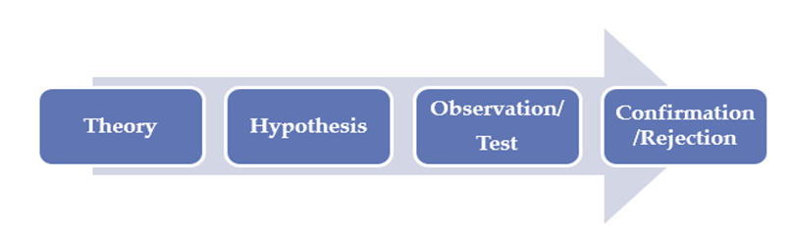

**Figure 3.1: Deductive Approach**

**3.3.2 Inductive Approach**

Inductive approach involves with the results of observations and theories. Beginning of the research, I didn’t apply theories and hypothesis in this type of research methods [22].



**Figure 3.2: Inductive Approach**

**3.4 Sample Study**

I have used the sampling technique to conduct the research in a successful way. Using the sampling technique among the probability of the sampling technique to gather the information effectively. I have selected sample of 200 respondents from people of population who are currently employed in different sectors to provide information in a better way.

**3.5 Sample size**

I have used a sample of 200 respondents for the research, these employees were selected randomly who doing jobs in different sectors in Sri Lanka. The sample respondents have given the answers to the questionnaires which is provided by me. Approximately 200 respondents from the target population were approached to ﬁll in the questionnaire. Out of 200 only 171 respondent’s data were valid.

**3.6 Data Collection Methods**

To collect the require information to the research from the employees and bachelor’s researcher use different methods. They are interviews, questionnaires and direct observations. From those methods, I searched the actual thoughts of people about the current system and the things they expect from the system.

Although there are various methods of data collection, as the researcher, I managed to choose the two main sources of data collection methods to carrying out my research. They are:

1. Primary source

2. Secondary source

The primary source refers to the sources of collecting original data in which I made. I made empirical approach such as personal interview. The secondary sources of data for this kind of research cannot be over emphasized. I obtained the secondary data from magazines, journals, newspapers and library source.

* **Direct Observation**

Direct observation is a method gathering evaluative information in which I get to see the subject in his or her usual environment without changing. So, I selected direct observation as major method to collect information. I mainly concern to recognize what data require in order to properly identify the problems facing. To properly identify the problem of the system users faced, I studied the manual system and I did observation how the different categories of people involve with the system. Carefully study and analyze the current systems and myself identified the problems and the causes of the problems.

* **Questionnaires**

A questionnaire is a set of printed or written questions with a selection of answers, devised for the purposes of a survey or statistical study. So, I made simple questionnaires to recognize and collect the important factors that influencing target categories of people. Researcher thought of make multiple choice questions because any age or any type of people can easily answer those types of questions and it will save the time of the people who are answering the questions. If people have spent lot of time to answer the questions, people may not like to give answers for those questions. Although those questions were made to do the statistical analysis, from the answers given by the different categories of people. So, I made different questionnaires. I gave those questionnaires to those categories of people and gathered the information that I needed.

* **Interviews**

Interviews are collecting data by asking people questions and following up their answers. Interviews are a standard part of qualitative research. Before conducting the interviews with different categories of people, the I had to decide to whom I need to do the interview to gather information. To collect information, I interviewed some employees who are working in different fields in Sri Lanka.

The interview method of data collection can be defined as a systematic way of collecting data or information from a respondent through asking questions directly from the respondent and collecting information with the aim of facilitating understanding. The oral interview was done between the author, employees and the chefs. Reliable facts were obtained based on the questions posed to the employees which help in starting the work also helped in the area of solution presentation of the new design.

During the interviews facts about what is happening came to light, together with the opinions of the interviewee regarding the system which is going to implement. I determined the areas to be discussed, listed the facts to be collected, solicited ideas, and used a variety of questions and then scheduled the dates, time and place for the interviews.

**3.7 Data examination**

I was using the SPSS 17 data examination software to do the analysis of results which I have collected from questionnaires throughout the research.

**3.8) Conceptual framework**

According to the literature review in chapter two, conceptual framework is designed using theoretical findings and hypothesis.

H1 H1

Convenience

Availability

H2

H3

Natural content

H4

Food Preference

Weight benefits

H5 H5

Sensory appeal

H6

Price

H7

Health concern

H8

Organic concern

**Figure 3.3: Conceptual framework**

**3.9 Research Hypothesis**

Service providers are trying to make money and trying to gain a competitive advantage to their job market. They can earn lot of money through an online website. They can save their time and reduce their costs. Employees are always wanting to eat homemade foods which is prepared by good chefs.

H1- There is a positive relationship between Convenience and Food Preference

H2 - There is a positive relationship between Availability and Food Preference

H3 - There is a positive relationship between Natural content and Food Preference

H4 - There is a positive relationship between Weight benefits and Food Preference

H5 - There is a positive relationship between Sensory appeal and Food Preference

H6 - There is a positive relationship between Price and Food Preference

H7 - There is a positive relationship between Health concern and Food Preference

H8 - There is a positive relationship between Organic concern and Food Preference

**3.10 Operationalization**

Impact of homemade food for employees ‘in Sri Lanka; the concept that is needed to be studied in this research. In previous chapters, I have mentioned the dimensions which is related to the concept of the study. Based on the literature I have found eight dimensions. They are Convenience, Availability, Natural content, Weight benefits, Sensory appeal, Price, Health concern and Organic concern. According to the literature dimension of food, preference is being operationalized. In the following table, I will explain how these mentioned dimensions are being operationalized and what are the based theories for these dimensions are being operationalized.

**3.10.1 Operationalization of Convenience**

**Table 3.1: Operationalization of Convenience**

|  |  |  |  |  |  |
| --- | --- | --- | --- | --- | --- |
| |  | | --- | | **Dimension** | | |  | | --- | | **Operationalization** | | |  | | --- | | **Based theory** | |
| Convenience | I always consider about convenience of the foods.  I don’t have time for cooking. However, I always like homemade foods.  Safety of the ready-made foods are very less.  I think that fast foods are more convenience than homemade foods | (Phyllis Maarsman , 2016 ) |

Based on “Phyllis Maarsman” theory, the I have made some questionnaires about the factor convenience. Consumers are looking for more useful food products in order to save their cooking time. Supermarkets are providing pre-cut vegetables and pre-cooked foods to the customers. Therefore, foods like fast foods or ready-made products are becoming more popular than homemade foods [4].

**3.10.2 Operationalization of Availability**

**Table 3.2: Operationalization of Availability**

|  |  |  |
| --- | --- | --- |
| **Dimension** | **Operationalization** | **Based theory** |
| Availability | I can easily choose any fast foods when it is available.  I can order fast foods anytime than homemade foods.  It is difficulty find homemade foods because it’s not available when I need.  When I order junk foods, they deliver as soon as possible. | (Farzana Quoquab Habib, Rozhan Abu Dardak & Sabarudin Zakaria , 2011 ) |

Based on the theory “Farzana Quoquab Habib, Rozhan Abu Dardak & Sabarudin Zakaria”, I have made the questionnaires about the factor availability to gather information from the employees. The factor “Availability” means actual availability of the purchasing foods in the nearest area. This means that consumers get a high score for this factor and do not want to walk longer to buy healthy foods. So, consumers with this factor, the offer is based on what is offered in shops near their homes or working places.

**3.10.3 Operationalization of Natural content**

|  |  |  |
| --- | --- | --- |
|  | **Table 3.3: Operationalization of Natural content** |  |

|  |  |  |
| --- | --- | --- |
| **Dimension** | **Operationalization** | **Based theory** |
| Natural content | I concern about use of natural ingredients of the foods to take the foods decisions.  I only concern about the natural content because it’s impact to my healthier lifestyle.  I like to eat foods which content natural ingredients.  Artificial ingredients foods create health issues to the people. | ( Mr.Vijayabaskar & Dr.N.Sundaram , 2012 ) |

Based on the theory “Mr.Vijayabaskar & Dr.N.Sundaram”, I have made the questionnaires which is related to the natural content. Consumers have increased their interest of foods which is included natural ingredients and packaging that they take decisions of food choices. Foods which is included natural ingredients means not including artificial ingredients.

**3.10.4 Operationalization of Weight benefits**

**Table 3.4: Operationalization of Weight benefits**

|  |  |  |
| --- | --- | --- |
| **Dimension** | **Operationalization** | **Based theory** |
| Weight benefits | I always like to eat low fat foods because it impacts to the heart issues.  Homemade foods are the healthier foods which is affects to the long living life.  I concern about my body weight. So, I prefer to eat healthier foods.  I know that I am over weighted because of my unhealthy food pattern. | ( Deborah R. Wahl, Karoline Villinger, Laura M. König, Katrin Ziesemer, Harald T. Schupp & Britta Renner, 2017) |

Based on the theory “Deborah R. Wahl, Karoline Villinger, Laura M. König, Katrin Ziesemer, Harald T. Schupp & Britta Renner”, I have made the questionnaires about the factor of Weight benefits. Nowadays most of the people are considering about their weight. To maintain the weight people need to control the foods when they are making the decisions of food choices. I have found that employees have poor eating behavior which means they have less nutrition foods and that is leading to became overweight and obesity.

**3.10.5 Operationalization of Sensory appeal**

**Table 3.5: Operationalization of Sensory appeal**

|  |  |  |
| --- | --- | --- |
| **Dimension** | **Operationalization** | **Based theory** |
| Sensory appeal | I am considering about the appearance, smell and taste when choosing the foods.  I would like to eat healthful foods if the foods are taste and look better.  I am eating any foods (fast foods or home made foods) if it is very tasty.  I think that good taste is necessary thing for the consumption of fruits and vegetables. | ( J Shepherd, A Harden, R Rees, G Brunton, J Garcia, S Oliver & A Oakley , 2006 ) |

Based on the theory of J Shepherd, A Harden, R Rees, G Brunton, J Garcia, S Oliver & A Oakley, the researcher has made the questionnaires which is related to the Sensory appeal. Sensory appeal is including appearance, smell and taste. The sensory appeal is more important when people make decisions about food choices. So, appearance, smell and taste of foods are very important when people choose the foods and thinking what to eat.

**3.10.6 Operationalization of Price**

**Table 3.6: Operationalization of Price**

|  |  |  |
| --- | --- | --- |
| **Dimension** | **Operationalization** | **Based theory** |
| Price | When making decisions of healthy food choices, price is a major barrier for me.  My income is not enough to buy healthy foods.  I prefer to buy cheaper foods from the food outlets.  I know that lower price foods are offering less quality and it is not good to our body. | (Williams, Thornton & Crawford, 2012) |

Based on the theory of “Williams, Thornton & Crawford,” I have made the questionnaires about the factor of Price. For most of the customers price and time are the wall when making the decisions about food choices Healthy foods are more expensive because those foods are helping to improve the health of human life. According to the French study has found that price reduction strategy is impacted to the healthy food choices. Also, big stores food products are cheaper than small stores food products and this leads to gain the weight.

**3.10.7 Operationalization of Health concern**

**Table 3.7: Operationalization of Health concern**

|  |  |  |
| --- | --- | --- |
| **Dimension** | **Operationalization** | **Based theory** |
| Health concern | I like to eat sugary foods instead of non – sugary foods like yogurts.  Healthy foods are beneficial for skin, teeth, hair and nails also increase the attractiveness.  Eating healthy foods prevent chronic disease.  I am always considering about my health. So, I avoid eating unhealthy foods. | (Sika Gasinu , 2015) |

Based on the theory of “Sika Gasinu”, I have made the questionnaires which is related to the health concern to gather the information from the employees. Functional foods are like healthful products which is added or removed unhealthy ingredients to improve the healthiness of the products [6]. People like to eat more foods which contain sugar instead of non-added sugar foods such as yogurt etc. Health concern means importance health condition of human body such as how to improve skin, teeth, hair and nails with the help of healthful products.

**3.10.8 Operationalization of Organic concern**

**Table3.8: Operationalization of Organic concern**

|  |  |  |
| --- | --- | --- |
| **Dimension** | **Operationalization** | **Based theory** |
| Organic concern | I would like to eat organic foods because it is beneficial to my body.  When I do shopping I prefer to go the section which is having organic foods.  My food eating behavior is changing based on the situation.  I always reflect about the safety of foods. | ( Elisabeth Von Essen & Magnus Englander, 2013) |

Based on the theory of “Elisabeth Von Essen & Magnus Englander”, I have made the questionnaires about the factor of organic concern. Today’s society is more concerned about food safety. Basha Bilal has mentioned that consumers’ food eating behavior can be changed based on their situation. Organic foods help to improve the health and bringing benefits. Most people are choosing organics foods when they are doing shopping and it is helpful their body and also the environment.

**3.10.9 Operationalization of Food Preference**

**Table 3.9: Operationalization of Food Preference**

|  |  |  |
| --- | --- | --- |
| **Dimension** | **Operationalization** | **Based theory** |
| Food Preference | I like only Homemade foods.  I like only Fast foods.  I like both Homemade and fast foods.  Lack of time is the main reason for choosing fast foods.  I prefer if I can order prepared foods online that are available within my city. | (Phyllis Maarsman , 2016 ) |

Based on the theory of “Phyllis Maarsman”, I have made the questionnaires about the factor Food preference to gather the information from the employees. Eating in outside become a trend in modern society. Consumers have very little knowledge of preparing homemade foods. In fact, food consumed outside the home is typically of poorer nutritional quality and served in larger portions. There is a positive association between the rise in eating out, higher energy intakes and increasing rates of obesity, a major health and wellbeing societal challenge in many Western nations.

**3.11 Independent Variables**

Convenience, Availability, Natural content, Weight benefits, Sensory appeal, Price, Health concern and Organic concern are the independent variables. Questionnaires were presented in a structured way. According to the questionnaires respondents were answered which they had to scale their level of involvement in to above independent variables which were indicated in the conceptual framework. The researcher has divided scale the level of involvement which is differs from strongly agree to strongly disagree.

1 = Strongly disagree

2 = Disagree

3 = Neither Disagree nor Agree

4 = Agree

5 = Strongly agree

I have structured four questionnaires to each and every dimension. Therefore, it is easy to answer to the questions for the respondents. The researcher has used the interval scale which can perform arithmetical operations from the data collections to the respondents. The interval scale allows the researcher to perform the gap between any two points of the scale.

**3.12 Dependent Variable**

In this study, the researcher has taken dependent variable as Food Preference. Because food preference is the main factor, the researcher is considered in this study. Sensory consumer research has confirmed that extrinsic product cues affect consumer perception of the food product sensory quality [7,8,9]. It has been reported that the brand name shown on a package influences consumer liking of taste of various food products [10,11]. The nutritional labeling also affects the estimation of taste [12]. In contrast, little is known about the relative effect of the extrinsic cues on the informed product evaluation when multiple cues are present [7].

**3.12.1 Scaling Food Preference**

Respondents were requested to evaluate the statement related to food preference. I have used the interval scale which can perform arithmetical operations from the data collections to the respondents and most preferred response will be given as five.

1 = Strongly Disagree

2 = Disagree

3 = Neither Disagree nor Agree

4 = Agree

5 = Strongly Agree

**3.13 summary**

In this chapter, I discuss about the methodology that the I am going to use to do the research. The methodology is a set or system of methods, principles, and rules for regulating a given discipline, as in the arts or science. The methodologies I have used in this research were discussed under the research design, data collection methods and the study sample. By doing those things mentioned previously, I got the whole idea about how he/ she want to do the research and gathered the necessary information for the research. I also understood if wrongly choose the methodology for the research whole research will fail. So, identifying the appropriate methodology for the research is the most important part of the research.

In the next chapter, I have described the data representation of the research. It totally shows the outcome of the research work that has carried out. It shows the analysis of the data that the researcher had collected, regarding this research.

**CHAPTER FOUR – DATA PRESENTATION**

**4.1 Introduction**

Under the methodology chapter, the researcher has discussed the data gathering formats. The methods they use in collecting data can be categorized as direct observations, interviews and questioners as they will help for me to get some more accurate and interesting data from the employees. Direct observation gives the best ideas on how the process going on as the researcher that I am witnessing it by each aspect.

So, I need to find another method to gather data. Then they use the method of interviews, which is another effective way of communicating with others. Through interviews, I could gather information to the point as anyone cannot refuses at that time. Next way of gathering data was questioners. This is not much effective way of gathering information but able to get more information.

The data representation chapter shows the results of gathers data. I have used SPSS tool for analyzing the data. In the research, that shows what I have found out with observations, interviews and questioners, This way I could get an idea about what is the path the researcher should go ahead. In this chapter, I needs to show the results in a way that the others can directly understandable way.

**4.2 Demographic factors analysis of sample.**

**Table 4.10: Demographic factors analysis of sample.**

|  |  |  |  |  |
| --- | --- | --- | --- | --- |
|  | Frequency | Percent | Valid percent | Cumulative  Percent |
| Male  Valid  Female  Total | 120  80  150 | 60  40  100.0 | 60  40  100.0 | 60  100.0  100.0 |

From the received analysis 60% percent of males have participated and 40% of females participated to do this study. According to the statistics report 68% of males eating fast or junks foods and 32% of females eating fast or junk foods. However, both are like to eat homemade foods. Because of the time they don’t have to cook meals. To some extent research, demographic factors are also the same.

**4.2.1 Age configuration of the study**

**Table 4.11: Age configuration of the study**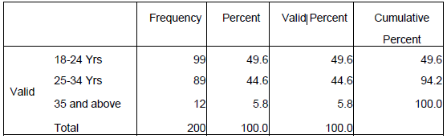

According to the above table 4.2, from age limit 18-24 years are the most of respondents are given that is 49.6% out of total sample. And the second- highest value is age limit 25-34 years which is a percentage 44.6% of the total sample.

**4.2.3 Level of Occupation**

**Table 4.12: Level of Occupation**

|  |  |  |  |  |
| --- | --- | --- | --- | --- |
|  | Frequency | Percent | Valid percent | Cumulative  Percent |
| Employeed    Valid  Self Employeed  Total | 129  71  200 | 60  40  100 | 60  40 | 60  100.0 |

According to the above table indicates level of occupational analysis. According to result of the chart, most of them are employed that is 60% from total sample. Then the second highest result is the full-time students who are studying.

**4.3 Fast foods liked by sample**

**Table 4.13: Fast foods liked by sample**

|  |  |  |
| --- | --- | --- |
| Brand | Frequency | Percentage |
| McDonalds | 18 | 9 |
| KFC | 30 | 15 |
| Burger King | 20 | 10 |
| Taco Bell | 12 | 6 |
| Pizza Hut | 18 | 9 |
| Dominos | 10 | 5 |
| Subway | 12 | 6 |
| Fab | 8 | 4 |
| Dinemore | 12 | 6 |

Most of participants like KFC, Burger King, McDonalds and Pizza Hut. They choose these foods because of the availability and time.

**4.4 Homemade food liked by sample**

**Table 4.14: Homemade food liked by sample**

|  |  |  |
| --- | --- | --- |
| Food | Frequency | Percentage |
| Kiri bath | 18 | 9 |
| Pittu | 16 | 8 |
| String Hoppers | 18 | 9 |
| Pol roti | 14 | 7 |
| Polos | 16 | 8 |
| Malu ambul thiyal | 18 | 9 |
| Kiri Kos | 18 | 9 |
| Soup | 16 | 8 |
| Rasam | 14 | 7 |
| Amaberella Curry | 16 | 8 |
| Amba Curry | 14 | 7 |
| Idly | 18 | 9 |

All the participants like to eat homemade foods. However, they do not have enough time for preparing homemade foods. If they have time or cooking they will not buy fast foods from the shops.

**4.5 Reliability and validity**

**Table 4.15: Reliability and validity**

|  |  |  |  |  |  |  |  |  |
| --- | --- | --- | --- | --- | --- | --- | --- | --- |
| Dimension | Reliability | | Validity | | | | | |
|  | CA  Standard  >0.7 | NI | KMO  >0.5 | BTS | Significance  <.05 | IR=  FL2 of each  Indicator  >.5 | CR  >.7 | AVE  >.5 |
| Convenience | .891 | 5 | .858 | 76.939 | .000 | C1= 0.643  C2= 0.796  C3= 0.776  C4= 0.654 | .92 | .7005 |
| Availability | .853 | 4 | .784 | 57.955 | .000 | A1= 0.773  A2= 0.579  A3= 0.701  A4= 0.828 | .91 | .7203 |
| Natural content | .853 | 4 | .784 | 57.955 | .000 | N1= 0.773  N2= 0.579  N3= 0.701  N4= 0.828 | .91 | .7203 |
| Weight benefits | .891 | 5 | .854 | 76.939 | .000 | WB1= 0.643  WB2= 0.796  WB3= 0.776  WB4= 0.654 | .92 | .7005 |
| Sensory appeal | .825 | 3 | .720 | 38.946 | .000 | SA1= 0.903  SA2= 0.362  SA3= 0.851  SA4= 0.896 | .90 | .7408 |
| Price | .891 | 5 | .858 | 76.939 | .000 | P1= 0.643  P2= 0.796  P3= 0.776  P4= 0.654 | .92 | .7005 |
| Health concern | .825 | 3 | .720 | 38.946 | .000 | HC1= 0.903  HC2= 0.362  HC3= 0.851  HC4= 0.896 | .90 | .7408 |
| Organic concern | .891 | 5 | .858 | 76.939 | .000 | OC1= 0.643  OC2= 0.796  OC3= 0.776  OC4= 0.654 | .92 | .7005 |
| Food Preference | .891 | 5 | .858 | 76.939 | .000 | FP1= 0.643  FP2= 0.796  FP3= 0.776  FP4= 0.654  FP5= 0.632 | .74 | .7005 |

**4.6 Correlations between Convenience and Availability**

**Table 4.16: Correlations between Convenience and Availability**

|  |  |  |
| --- | --- | --- |
|  | Convenience Mean | Availability Mean |
| Convenience Person Correlation  Mean Sig. (2-tailed)  N    Availability Person Correlation  Mean Sig. (2-tailed)  N | .7005    30      .405  .026  30 | .7203  30 |

**4.7 Impact on Convenience on Food preference**

According to the literature, I have developed the following objectives that need to be response

• To observe the relationship between Convenience on food preference in consumers

To achieve this objective, the researcher has developed the following hypotheses.

**4.7.1 Correlations of Convenience and Food Preference**

**Table 4.17: Correlations of Convenience and Food Preference**

|  |  |  |
| --- | --- | --- |
|  | Convenience | Food Preference |
| Pearson Correlation  Convenience Sig. (2-tailed)  N  Pearson Correlation  Food Preference Sig. (2-tailed)  N | 1    200  .520**  .000  200 | .520**  .000  200  1  200 |

According to the result of above table correlation of convenience and food preference is 0.520 at a0.001 significant level. That means there is positive relationship between those two variables called convenience and food preference.

**4.7.2 Regression analysis of Convenience and Food Preference**

**Model Summary**

**Table 4.18: Model Summary**

|  |  |
| --- | --- |
| R  R Square  Adjusted R Square  Std. Error of the Estimate | .520  .274  .269  2.418 |

**ANOVA**

**Table 4.19: ANOVA**

|  |  |  |  |  |  |
| --- | --- | --- | --- | --- | --- |
|  | Sum of Squares | Df | Mean Square | F | Sig. |
| Regression  Residual  Total | 328.500  866.072  1195.573 | 1  198  199 | 329.500  5.452 | 54.307 | .000 |

**Coefficients**

**Table 4.20: Coefficients**

|  |  |  |  |  |
| --- | --- | --- | --- | --- |
|  | Unstandardized Coefficients  B Std. Error | Standardized  Coefficients  Beta | t | Sig. |
| (Constant)  Convenience | 14.152 .987  .382 .051 | .520 | 14.333  7.604 | .000  .000 |

**4.7.3 Significance test of Convenience and Food Preference**

According to the results of regression analysis in the table, beta coefficient displays as 0.520. Based on the results in the table,I linear calculates relationship between these two variables.

* **H0**: there is a negative relationship between Convenience and Food Preference
* **H1**: there is a positive relationship between Convenience and Food Preference

The intercept, *a* isequals to 14.152, and the slope, *b* isequals to .382. The standard error of *b* is estimated as .051 and the value of the *t* statistic is *t* = 7.604, with *n*-2 =198 degrees of freedom. Researcher has recognized that the critical value of *t* with 148 degrees of freedom and α = 0.05 is 1.9759 for a two-tailed test. Then the calculated value 7.604, is larger than the critical value 1.9759, the null hypotheses is rejected. Later there is a 32. There is significant impact between Convenience and Food preference in employees in Sri Lanka

Therefore, it can be expected that people are considering more about the Convenience when they are buying foods from their food preference.

**4.8 Correlations of Availability and Food Preference**

**Table 4.21: Correlations of Availability and Food Preference**

|  |  |  |
| --- | --- | --- |
|  | Availability | Food Preference |
| Pearson Correlation  Availability Sig. (2-tailed)  N  Pearson Correlation  Food Preference Sig. (2-tailed)  N | 1    200  .534**  .000  200 | .534**  .000  200  1  200 |

According to the result of above table correlation of availability and food preference is 0.534 at a 0.001 significant level. That means there is positive relationship between those two variables called availability and food preference.

**4.8.1 Regression analysis between Availability and Food Preference**

**Model Summary**

**Table 4.22: Model Summary**

|  |  |
| --- | --- |
| R  R Square  Adjusted R Square  Std. Error of the Estimate | .534  .287  .282  2.396 |

**ANOVA**

**Table 4.23: ANOVA**

|  |  |  |  |  |  |
| --- | --- | --- | --- | --- | --- |
|  | Sum of Squares | Df | Mean Square | F | Sig. |
| Regression  Residual  Total | 343.113  853.461  1196.574 | 1  198  199 | 343.113  5.852 | 58.838 | .000 |

**Coefficient**

**Table 4.24: Coefficient**

|  |  |  |  |  |
| --- | --- | --- | --- | --- |
|  | Unstandardized Coefficients  B Std. Error | Standardized  Coefficients  Beta | t | Sig. |
| (Constant)  Availability | 15.271 .828  .447 .057 | .534 | 18.410  7.835 | .000  .000 |

**4.8.2 Significance test of Availability and Food Preference**

According to the results of regression analysis in the beta coefficient displays as 0.534. Based on the results in the table, I linear calculates relationship between these two variables.

• **H0**: there is a negative relationship between Availability and Food Preference

• **H1**: there is a positive relationship between Availability and Food Preference

The intercept, *a* is equals to 15.271, and the slope, *b* is equals to .447. The standard error of *b* is estimated as .057 and the value of the *t* statistic, *t* = 7.835, with n-2 =198 degrees of freedom. Researcher has recognized that the critical value of t with 198 degrees of freedom and α = 0.05 is 1.9759 for a two-tailed test. Then the calculated value of *t* 7.835, is larger than the critical value 1.9759, the null hypotheses is rejected. Later there is a significant impact between Availability and Food Preference employees in Sri Lanka.

**4.9 Correlations of Natural content and Food Preference**

**Table 4.25: Correlations of Natural content and Food Preference**

|  |  |  |
| --- | --- | --- |
|  | Natural content | Food Preference |
| Pearson Correlation  Natural content Sig. (2-tailed)  N  Pearson Correlation  Food Preference Sig. (2-tailed)  N | 1    200  .530**  .000  200 | .530**  .000  200  1  200 |

According to the result of above table correlation of Natural content and food preference is 0.490 at a0.001 significant level. That means there is positive relationship between those two variables called Natural content and food preference.

**4.9.1 Regression analysis between Natural Content and Food Preference**

**Model Summary**

**Table 4. 26: Model Summary**

|  |  |
| --- | --- |
| R  R Square  Adjusted R Square  Std. Error of the Estimate | .530  .284  .278  2.402 |

**ANOVA**

**Table 4.27: ANOVA**

|  |  |  |  |  |  |
| --- | --- | --- | --- | --- | --- |
|  | Sum of Squares | Df | Mean Square | F | Sig. |
| Regression  Residual  Total | 336.118  858.096  1194.214 | 1  198  199 | 343.113  5.752 | 56.658 | .000 |

**Coefficient**

**Table 4.28: Coefficient**

|  |  |  |  |  |
| --- | --- | --- | --- | --- |
|  | Unstandardized Coefficients  B Std. Error | Standardized  Coefficients  Beta | t | Sig. |
| (Constant)  Natural Content | 14.682 .862  .402 .055 | .530 | 17.652  7.814 | .000  .000 |

**4.9.2 Significance test of Natural Content and Food Preference**

According to the results of regression analysis in the table, beta coefficient displays as 0.530. Based on the results in the table, I linear calculates relationship between these two variables.

* **H0**: there is a negative relationship between Convenience and Food Preference
* **H1**: there is a positive relationship between Convenience and Food Preference

The intercept, *a* is equals to 14.682, and the slope, *b* is equals to .402. The standard error of *b* is estimated as .055 and the value of the *t* statistic, *t* = 7.814, with n-2 =198 degrees of freedom. The researcher has recognized that the critical value of t with 198 degrees of freedom and α = 0.05 is 1.9759 for a two-tailed test. Then the calculated value of *t* 7.814, is larger than the critical value 1.9759, the null hypotheses is rejected. Later there is a significant impact between Natural Content and Food Preference employees in Sri Lanka.

**4.10 Correlations of Weight benefits and Food Preference**

**Table 4.29: Correlations of Weight benefits and Food Preference**

|  |  |  |
| --- | --- | --- |
|  | Weight benefits | Food Preference |
| Pearson Correlation  Weight benefits Sig. (2-tailed)  N  Pearson Correlation  Food Preference Sig. (2-tailed)  N | 1    200  .520**  .000  200 | .520**  .000  200  1  200 |

According to the result of above table correlation Weight benefits and food preference is 0.520 at a0.001 significant level. That means there is positive relationship between those two variables called Weight benefits and food preference.

**4.10.1 Regression analysis between Weight benefits and Food Preference**

**Model Summary**

**Table 4.30: Model Summary**

|  |  |
| --- | --- |
| R  R Square  Adjusted R Square  Std. Error of the Estimate | .520  .274  .269  2.418 |

**ANOVA**

**Table 4.31: ANOVA**

|  |  |  |  |  |  |
| --- | --- | --- | --- | --- | --- |
|  | Sum of Squares | Df | Mean Square | F | Sig. |
| Regression  Residual  Total | 328.500  866.072  1195.573 | 1  198  199 | 329.500  5.452 | 54.307 | .000 |

**Coefficients**

**Table 4.32: Coefficients**

|  |  |  |  |  |
| --- | --- | --- | --- | --- |
|  | Unstandardized Coefficients  B Std. Error | Standardized  Coefficients  Beta | t | Sig. |
| (Constant)  Weight benefits | 14.152 .987  .382 .051 | .520 | 14.333  7.604 | .000  .000 |

**4.10.2 Significance test of Weight benefits and Food Preference**

According to the results of regression analysis in the table, beta coefficient displays as 0.520. Based on the results in the table, I linear calculates the relationship between these two variables.

* **H0**: there is a negative relationship between Weight benefits and Food Preference
* **H1**: there is a positive relationship between Weight benefits and Food Preference

The intercept, *a* isequals to 14.152, and the slope, *b* isequals to .382. The standard error of *b* is estimated as .051 and the value of the *t* statistic is *t* = 7.604, with *n*-2 =198 degrees of freedom. The researcher has recognized that the critical value of *t* with 148 degrees of freedom and α = 0.05 is 1.9759 for a two-tailed test. Then the calculated value 7.604, is larger than the critical value 1.9759, the null hypotheses is rejected. Later there is a 32. There is a significant impact between Weight benefits and Food preference in employees in Sri Lanka

Therefore, it can be expected that people are considering more about the Weight benefits when they are buying foods from their food preferences.

**4.11 Correlations of Sensory appeal and Food Preference**

**Table 4.33: Correlations of Sensory appeal and Food Preference**

|  |  |  |
| --- | --- | --- |
|  | Sensory appeal | Food Preference |
| Person Correlation  Sensory appeal Sig. (2-tailed)  N  Person Correlation  Food Preference Sig. (2-tailed)  N | 1    200  .540**  .000  200 | .540**  .000  200  1  200 |

According to the result of above table correlation Sensory appeal and food preference is 0.540 at a0.001 significant level. That means there is positive relationship between those two variables called Sensory appeal and food preference.

**4.11.1) Regression analysis between Sensory appeal and Food Preference**

**Model Summary**

**Table 4.34: Model Summary**

|  |  |
| --- | --- |
| R  R Square  Adjusted R Square  Std. The error of the Estimate | .540  .295  .287  2.386 |

**ANOVA**

**Table 4.35: ANOVA**

|  |  |  |  |  |  |
| --- | --- | --- | --- | --- | --- |
|  | Sum of Squares | Df | Mean Square | F | Sig. |
| Regression  Residual  Total | 342.508  850.026  1192.534 | 1  198  199 | 348.420  5.996 | 58.836 | .000 |

**Coefficients**

**Table 4.36: Coefficients**

|  |  |  |  |  |
| --- | --- | --- | --- | --- |
|  | Unstandardized Coefficients  B Std. Error | Standardized  Coefficients  Beta | t | Sig. |
| (Constant)  Sensory appeal | 15.062 .784  .496 .061 | .540 | 19.983  8.024 | .000  .000 |

**4.11.2 Significance test of Sensory appeal and Food Preference**

According to the results of regression analysis in the table, beta coefficient displays as 0.540. Based on the results in the table, I linear calculates relationship between these two variables.

* **H0:** there is a negative relationship between Convenience and Food Preference
* **H1:** there is a positive relationship between Convenience and Food Preference

The intercept, *a* is equals to 15.062, and the slope, *b* is equals to .496. The standard error of *b* is estimated as .061 and the value of the *t* statistic, *t* = 8.024, with n-2 =198 degrees of freedom. The researcher has recognized that the critical value of t with 198 degrees of freedom and α = 0.05 is 1.9759 for a two-tailed test. Then the calculated value of *t* 8.024, is larger than the critical value 1.9759, the null hypotheses is rejected. Later there is a significant impact between Sensory appeal and Food Preference employees in Sri Lanka.

**4.12 Correlations of Price and Food Preference**

**Table 4.37: Correlations of Price and Food Preference**

|  |  |  |
| --- | --- | --- |
|  | Price | Food Preference |
| Person Correlation  Price Sig. (2-tailed)  N  Person Correlation  Food Preference Sig. (2-tailed)  N | 1    200  .510**  .000  200 | .510**  .000  200  1  200 |

According to the result of the above table correlation Price and food, preference is 0.510 at a0.001 significant level. That means there is a positive relationship between those two variables called price and food preference.

**4.12.1 Regression analysis between Price and Food Preference**

**Model Summary**

**Table 4.38: Model Summary**

|  |  |
| --- | --- |
| R  R Square  Adjusted R Square  Std. Error of the Estimate | .510  .267  .259  2.432 |

**ANOVA**

**Table 4.39: ANOVA**

|  |  |  |  |  |  |
| --- | --- | --- | --- | --- | --- |
|  | Sum of Squares | Df | Mean Square | F | Sig. |
| Regression  Residual  Total | 320.460  874.526  1194.986 | 1  198  199 | 321.420  5.382 | 53.956 | .000 |

**Coefficients**

**Table 4.40: Coefficients**

|  |  |  |  |  |
| --- | --- | --- | --- | --- |
|  | Unstandardized Coefficients  B Std. Error | Standardized  Coefficients  Beta | t | Sig. |
| (Constant)  Price | 13.846 .998  .362 .046 | .510 | 14.003  7.380 | .000  .000 |

**4.12.2 Significance test of Price and Food Preference**

According to the results of regression analysis in the table, beta coefficient displays as 0.510. Based on the results in the table, I linear calculates relationship between these two variables.

* **H0**: there is a negative relationship between Price and Food Preference
* **H1:** there is a positive relationship between Price and Food Preference

The intercept, *a* is equals to 15.062, and the slope, *b* is equals to .496. The standard error of *b* is estimated as .061 and the value of the *t* statistic, *t* = 8.024, with n-2 =198 degrees of freedom. The researcher has recognized that the critical value of t with 198 degrees of freedom and α = 0.05 is 1.9759 for a two-tailed test. Then the calculated value of *t* 8.024, is larger than the critical value 1.9759, the null hypotheses is rejected. Later there is a significant impact between Sensory appeal and Food Preference employees in Sri Lanka.

**4.13 Correlations of Health Concern and Food Preference**

**Table 4. 41: Correlations of Health Concern and Food Preference**

|  |  |  |
| --- | --- | --- |
|  | Health Concern | Food Preference |
| Person Correlation  Health Concern Sig. (2-tailed)  N  Person Correlation  Food Preference Sig. (2-tailed)  N | 1    200  .530**  .000  200 | .530**  .000  200  1  200 |

According to the result of above table correlation Health Concern and food preference is 0.530 at a0.001 significant level. That means there is positive relationship between those two variables called Health Concern and food preference.

**4.13.1 Regression analysis between Health Concern and Food Preference**

**Model Summary**

**Table 4.42: Model Summary**

|  |  |
| --- | --- |
| R  R Square  Adjusted R Square  Std. Error of the Estimate | .530  .284  .278  2.402 |

**ANOVA**

**Table 4.43: ANOVA**

|  |  |  |  |  |  |
| --- | --- | --- | --- | --- | --- |
|  | Sum of Squares | Df | Mean Square | F | Sig. |
| Regression  Residual  Total | 336.118  858.096  1194.214 | 1  198  199 | 343.113  5.752 | 56.658 | .000 |

**Coefficient**

Table 4.44: Coefficient

|  |  |  |  |  |
| --- | --- | --- | --- | --- |
|  | Unstandardized Coefficients  B Std. Error | Standardized  Coefficients  Beta | t | Sig. |
| (Constant)  Health Concern | 14.682 .862  .402 .055 | .530 | 17.652  7.814 | .000  .000 |

**4.13.2 Significance test of Health Concern and Food Preference**

According to the results of regression analysis in the table, beta coefficient displays as 0.530. Based on the results in the table, the researcher linear calculates relationship between these two variables.

* **H0**: there is a negative relationship between Health Concern and Food Preference
* **H1**: there is a positive relationship between Health Concern and Food Preference

The intercept, *a* is equals to 14.682, and the slope, *b* is equals to .402. The standard error of *b* is estimated as .055 and the value of the *t* statistic, *t* = 7.814, with n-2 =198 degrees of freedom. The researcher has recognized that the critical value of t with 198 degrees of freedom and α = 0.05 is 1.9759 for a two-tailed test. Then the calculated value of *t* 7.814, is larger than the critical value 1.9759, the null hypotheses is rejected. Later there is a significant impact between Natural Content and Food Preference employees in Sri Lanka.

**4.14 Correlations of Organic Concern and Food Preference**

**Table 4.45: Correlations of Organic Concern and Food Preference**

|  |  |  |
| --- | --- | --- |
|  | Organic Concern | Food Preference |
| Person Correlation  Organic Concern Sig. (2-tailed)  N  Person Correlation  Food Preference Sig. (2-tailed)  N | 1    200  .560**  .000  200 | .560**  .000  200  1  200 |

According to the result of above table correlation, Organic Concern and food preference is 0.560 at a0.001 significant level. That means there is a positive relationship between those two variables called Organic Concern and food preference.

**4.14.1 Regression analysis between Organic Concern and Food Preference**

**Model Summary**

**Table 4.46: Model Summary**

|  |  |
| --- | --- |
| R  R Square  Adjusted R Square  Std. Error of the Estimate | .560  .320  .296  2.342 |

**ANOVA**

**Table 4.47: ANOVA**

|  |  |  |  |  |  |
| --- | --- | --- | --- | --- | --- |
|  | Sum of Squares | Df | Mean Square | F | Sig. |
| Regression  Residual  Total | 362.108  848.296  1210.404 | 1  198  199 | 364.203  6.236 | 60.324 | .000 |

**Coefficient**

**Table 4.48: Coefficient**

|  |  |  |  |  |
| --- | --- | --- | --- | --- |
|  | Unstandardized Coefficients  B Std. Error | Standardized  Coefficients  Beta | t | Sig. |
| (Constant)  Organic Concern | 15.352 .692  .512 .066 | .560 | 20.428  8.234 | .000  .000 |

**4.14.2 Significance test of He Organic Concern and Food Preference**

According to the results of regression analysis in the table, beta coefficient displays as 0.560. Based on the results in the table, I linear calculates relationship between these two variables.

* **H0:** there is a negative relationship between Organic Concern and Food Preference
* **H1**: there is a positive relationship between Organic Concern and Food Preference

The intercept, *a* is equals to 15.352, and the slope, *b* is equals to .512. The standard error of *b* is estimated as .066 and the value of the *t* statistic, *t* = 8.234, with n-2 =198 degrees of freedom. The researcher has recognized that the critical value of t with 198 degrees of freedom and α = 0.05 is 1.9759 for a two-tailed test. Then the calculated value of *t* 8.234, is larger than the critical value 1.9759, the null hypotheses is rejected. Later there is a significant impact between Natural Content and Food Preference employees in Sri Lanka.

## **4.15 Summery**

## 

In this chapter, I have tried to point out the results, he/she gains from the various methods the researcher used to gather information and how the users think about the new system. It was generally a positive approach done by the researcher was able to gain a positive result. Mainly the researcher pays the attention towards the employees who are doing the jobs in Colombo city.

The designing of the application was done by considering each of the results analyzed of the interviews, questionnaires, and direct observation methods. The data representation which clearly shows that there are problems in consumers’ consumption pattern of foods

Then in the next chapter, the group is going to discuss about design part of the system as how the system flow goes on. An ER diagram will explain the system clearly. Mainly the researcher will be discussing about the implementation plan for the application. In order to get the things done in proper order, the researcher is planning to use many other third- party tools for data mapping and modeling.

**CHAPTER FIVE -** **SYSTEM DESIGN**

**5.1 Introduction**

In this chapter, researcher will explain the implementation plan of the proposed application. The researcher is planning to use many other third-party tools for the data mapping and modeling. The researcher will design a use case diagram in order to give a rough outline for the application which going to implement. The Entity- Relationship (ER) Diagram will give a rough idea for the user of the application. It will provide the details in the application addresses all the parties who are facing the current problem.

This chapter will provide a theoretical view of the entire application. Based on the data collected from the participants' system will be designed. This application is very user- friendly. Therefore, anyone can use this application easily.

**5.2 Design Methodology**

This section describes the performance of the application that the developer should enhance. The application did not get too much of space in the memory. The system should be easily extensible to add new functionalities at a later stage. It should also be easily modifiable to make changes to the features and functionalities. From the end users’ perspective, the system should be designed in such a way that it is easy to learn and use, efficient and having few errors if any. One best case is the issue of security versus response time. Checking User-Id and Password before a user can enter to the system creates a response time problem/overhead.

Initially, the researcher has been planning to use plenty of data modeling techniques. Many of the data modeling techniques were chosen on the theoretical knowledge the researcher had. However, from the point they planned to apply to the real situation, they noticed how difficult it is to map the data objects with the system entities and with real- world objects. Therefore, the researcher had to use some common and simple data modeling techniques to make things easy. For example, the researcher is planning to use Entity- Relationship diagrams, to accomplish the data modeling tasks in creating the database sections of the site. Further, Use case, Sequence and Data flow diagrams will be used to make sure that all the data is in the correct move. Further some advanced tools will be used to carry out the design part of the system.

This chapter also includes the testing part of the application. The researcher has used different types of testing in order to find out the errors in the bugs. The researcher has found some bugs when the application is testing. Those founded bugs are resolved by the researcher.

**5.3 Architecture of the System**

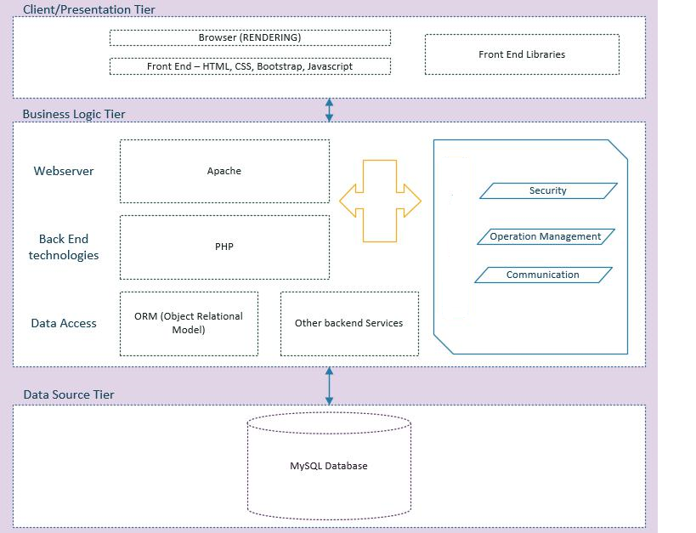Using three- tier architecture diagram for the application is shown below.

Figure 5.1: Three tier architecture diagram

**Figure 5.1: Three tier architecture diagram**

Researcher has used the three-tier architecture design to develop this application. First layer of the diagram which is called presentation layer has the front-end scripts, front end related activities, styles, libraries and the browsers, and these are called as client side of the system. Business layer of the architecture includes the technologies such as PHP, Apache. This layer has security, operation management, and communication. The final layer of architecture which is known as data source tier where the database is located.

**5.4 Design**

**5.4.1 Entity Relation Diagram**

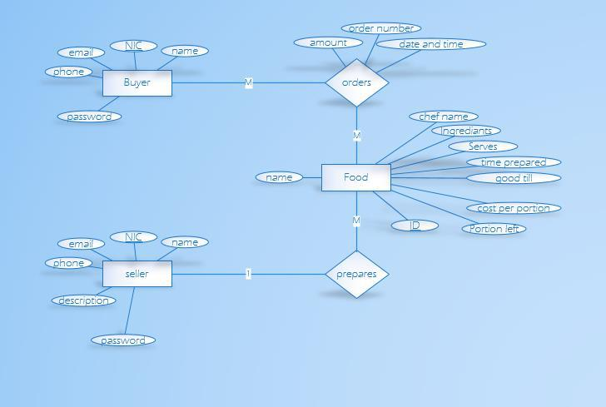

**Figure 5.2: ER Diagram**

The analysis of users of the system and entities, this Entity Relationship Diagram (ERD) was created by the researcher. In this system researcher has identified three main entities. The entities are Foods, Order and Users. The users of the system are Buyers and Sellers. The user attributes are name, email, phone, description, NIC and password. The main attributes of the food is chef name, ingredients, serves, time prepared, good till, portions and cost. In the Entity Relationship Diagram (ERD), order is a weak entity which contains amount, order number and time.

**5.4.2 Sequence diagram**

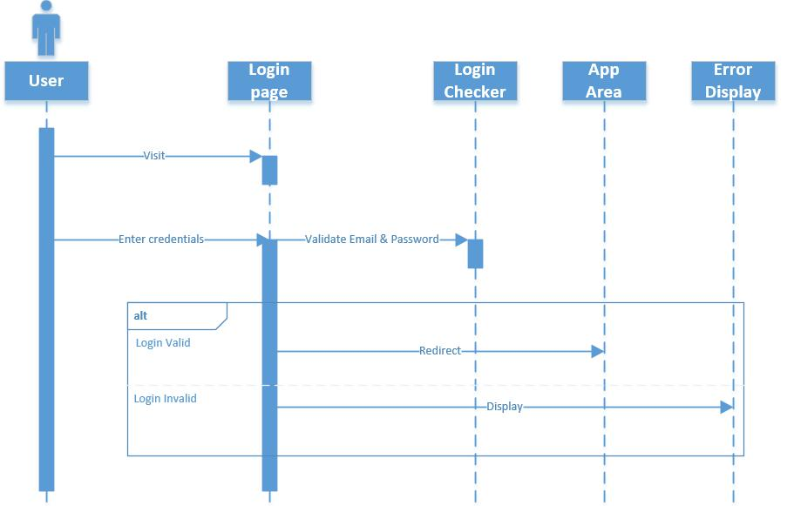

**Figure 5.3: Sequence diagram**

The above sequence diagram displays the authentication sequence for the application. Login sequence can be validating as valid and invalid response successfully by the users of the application. User needs to input correct credentials to the user in order to login to the system successfully. When user inputs the credential, the system will be validating the credentials where it is correct or not. Once the user is logging to the system correctly, the page will generate to home page of the application. The user will get a successful login message once the credentials are correct.

**5.4.3 Flowchart (logical)**

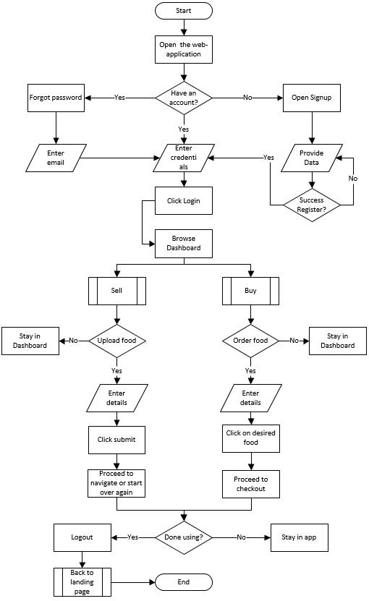

**Figure 5.4: Flowchart**

A flowchart is a diagram which is described a workflow of a system. In this study, the researcher has created a flowchart that described the workflow of the developed application.

First open the web application. If it is a new seller, he/ she needs to register to the system. Then seller needs to enter the name, e-mail address, NIC, phone number, need to write a description about the seller and finally create a new password. Next the login page will appear in the system. Seller needs to enter the valid credentials. Then menu page will load. In the menu page seller can add foods by clicking the food store button. When clicking the add foods, seller can enter the foods details to the web application. After adding the foods seller cab edit the food details if he/she wants by clicking the edit button also seller can delete the food by clicking the delete button if he/she wants. When buyer ordered food, seller is getting a notification and seller can see the order details by clicking the order button. Seller can see his/her seller details by clicking the user details button. Seller can make suggestions and get customer service by clicking contact us button.

For the buyer, he /she needs to open the application first. If it is a new buyer, he/she needs to register to the system. Then buyer needs to enter the name, e-mail address, NIC, phone number and need to create a new password. Next buyer need to enter the valid credentials to login to the system. Then menu page will appear on the system. Buyer can see the available foods by clicking food details. Buyer can select the food according to his/her food preference. By clicking buy now button buyer can order the foods. In place order page buyer can enter how many potions he/she needs. By clicking place order button, buyer can place the order. Then he/she can see the order details in order details page. Buyer can see his/her buyer details by clicking the user details button. Buyer can make suggestions and get customer service by clicking contact us button.

**5.4.5 Use case**

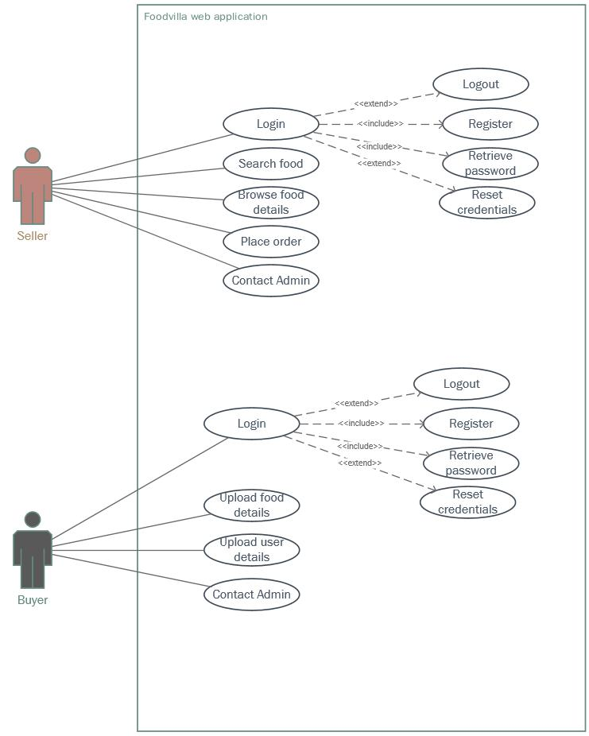

**Figure 5.5: Use Case Diagram**

Use case diagram is a representation about how users behave with the system. Seller registered to the system by providing correct details. If seller forgets his/ her credentials he/ she can reset the password. Seller uploads his/ her details and seller uploads to the food details to the system. If seller needs to contact the admin he/she can contact the admin.

Buyer can register to the system by providing correct details. If seller forgets his/ her credentials he/ she can reset the password. Buyer is searching the foods and brown food details. According to the buyer’s food preference he/ she can order the foods. If buyer needs to contact the admin he/she can contact the admin.

**5.6 Screen Designs of the Application**

**5.6.1 Sign up page for Seller**

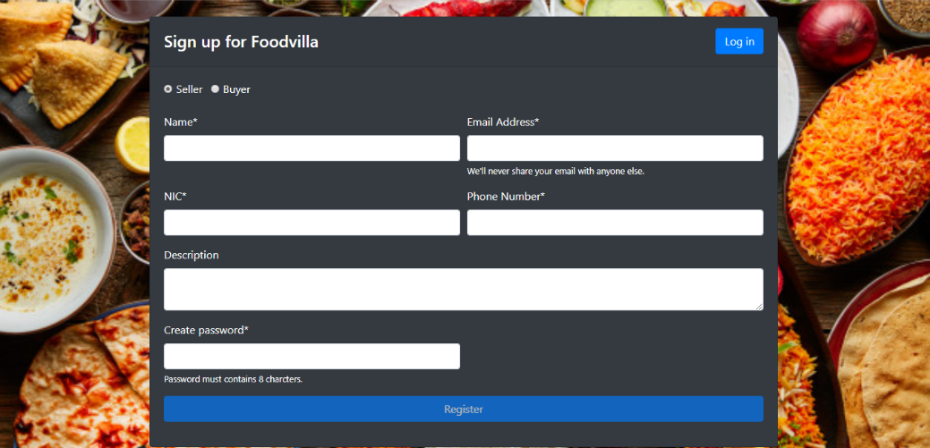

**Figure 5.6: Sign up page for Seller**

This is seller registering page. Seller can register to the system by providing name, e-mail address, NIC, Phone number, seller description and creating a new password.

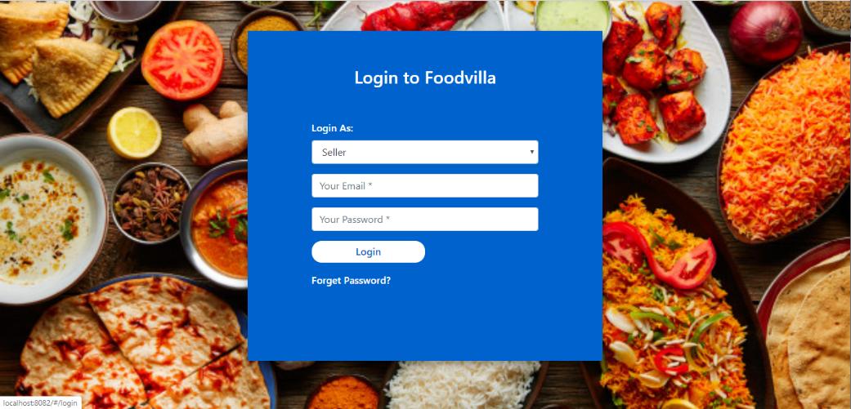**5.6.2 Login page for Seller**

**Figure 5.7: Login page for Seller**

This is seller login page. Seller can login to the system by providing valid credentials.

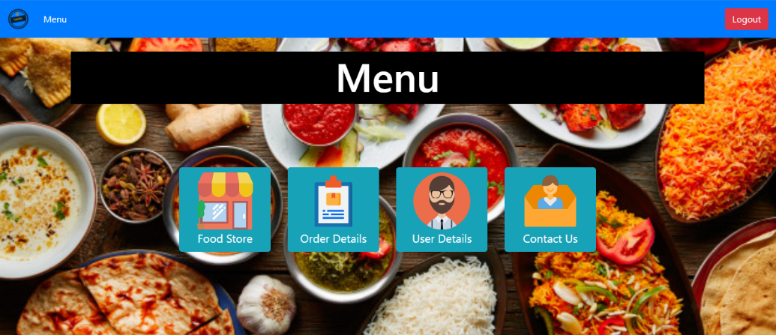**5.6.3 Seller Home page**

**Figure 5.8: Seller Home page**

This is seller home page. In this page, it contains food details, order details, user details and admin details.

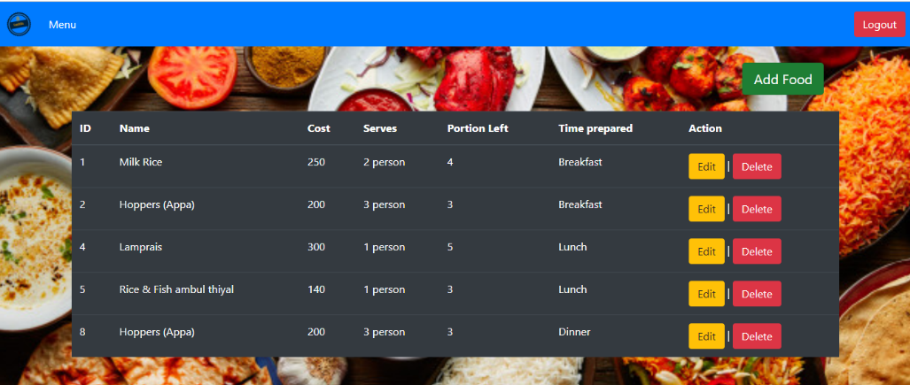**5.6.4 Seller Food menu**

**Figure 5.9: Seller Food menu**

This is seller food details page. In this page it has food name, price, serves and how many portion has left

**5.6.8 Buyer Sign up Page**

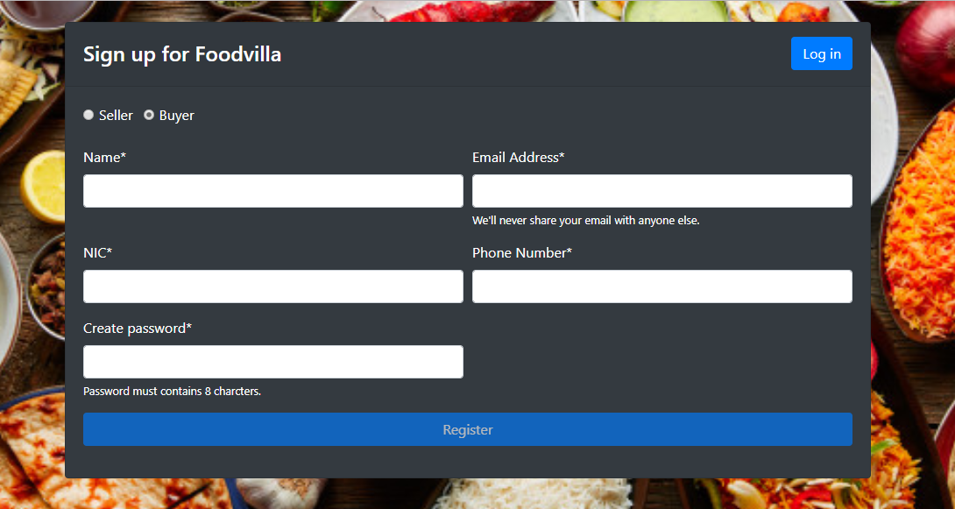

**Figure 5.13: Buyer Sign up Page**

This buyer registering page. Buyer can register to the system by providing correct details such as name, e-mail address, NIC, phone number and create new password.

**5.6.9 Buyer Login Page**

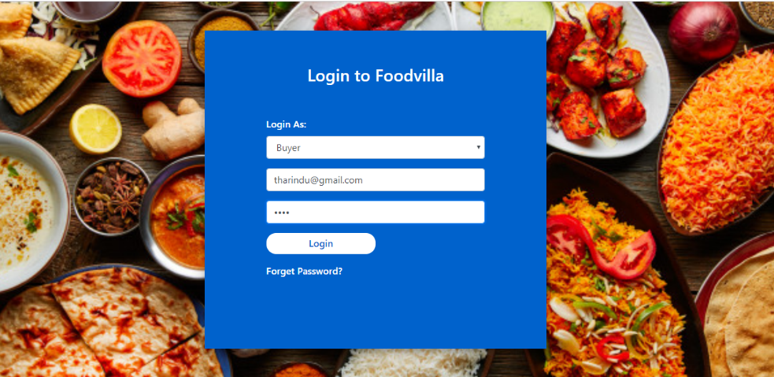

**Figure 2.14: Buyer Login Page**

Buyer can login to the system by providing valid credentials.

**5.6.10) Buyer Home page**

**Figure 5.15: Buyer Home page**

This is buyer home page. In this page it has food details, order details, buyer details and admin details.

**5.6.11 Buyer Menu page**

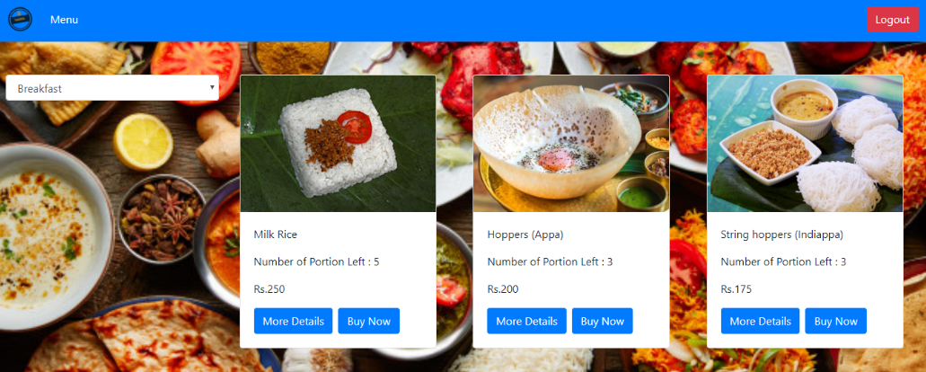

**Figure 5.16: Buyer Menu page**

This is buyer menu page. Buyer can see the available foods in the system. By clicking Buy now button buyer can order the food according to his/ her food preference.

**5.7 Debugging/Testing**

After developing the application, the application can have errors/ bugs. And process of solving bugs are known as debugging. Testing is done by Software Quality Assurance Engineers. In the software world there are various types of testing. In this applications researcher has founds several bugs. Those bugs are fixed and following test results is displaying in the tables.

Researcher has done the testing part to in order to identify the bugs in the implemented application. Those identified bugs were fixed. To work the application properly, fixing the bugs is real important in software development. Researcher has done manual testing to find the bugs. Manual testing means process of finding out what works and what doesn't in the developed application. This usually involves checking all the functions listed in the requirements documents, but often includes test software with their end users. Manual inspection plans include fully written test cases, detailed tests for examiners, and high-level instruction in expected results as well as exploratory testing sessions.

Testing is very important to ensure product quality .High quality products offered can gain the attractiveness of the software. If the quality of the application design is very well, it will work well, even if it works at peak performance. With well-proven results, can configure the software to work at suboptimal times.

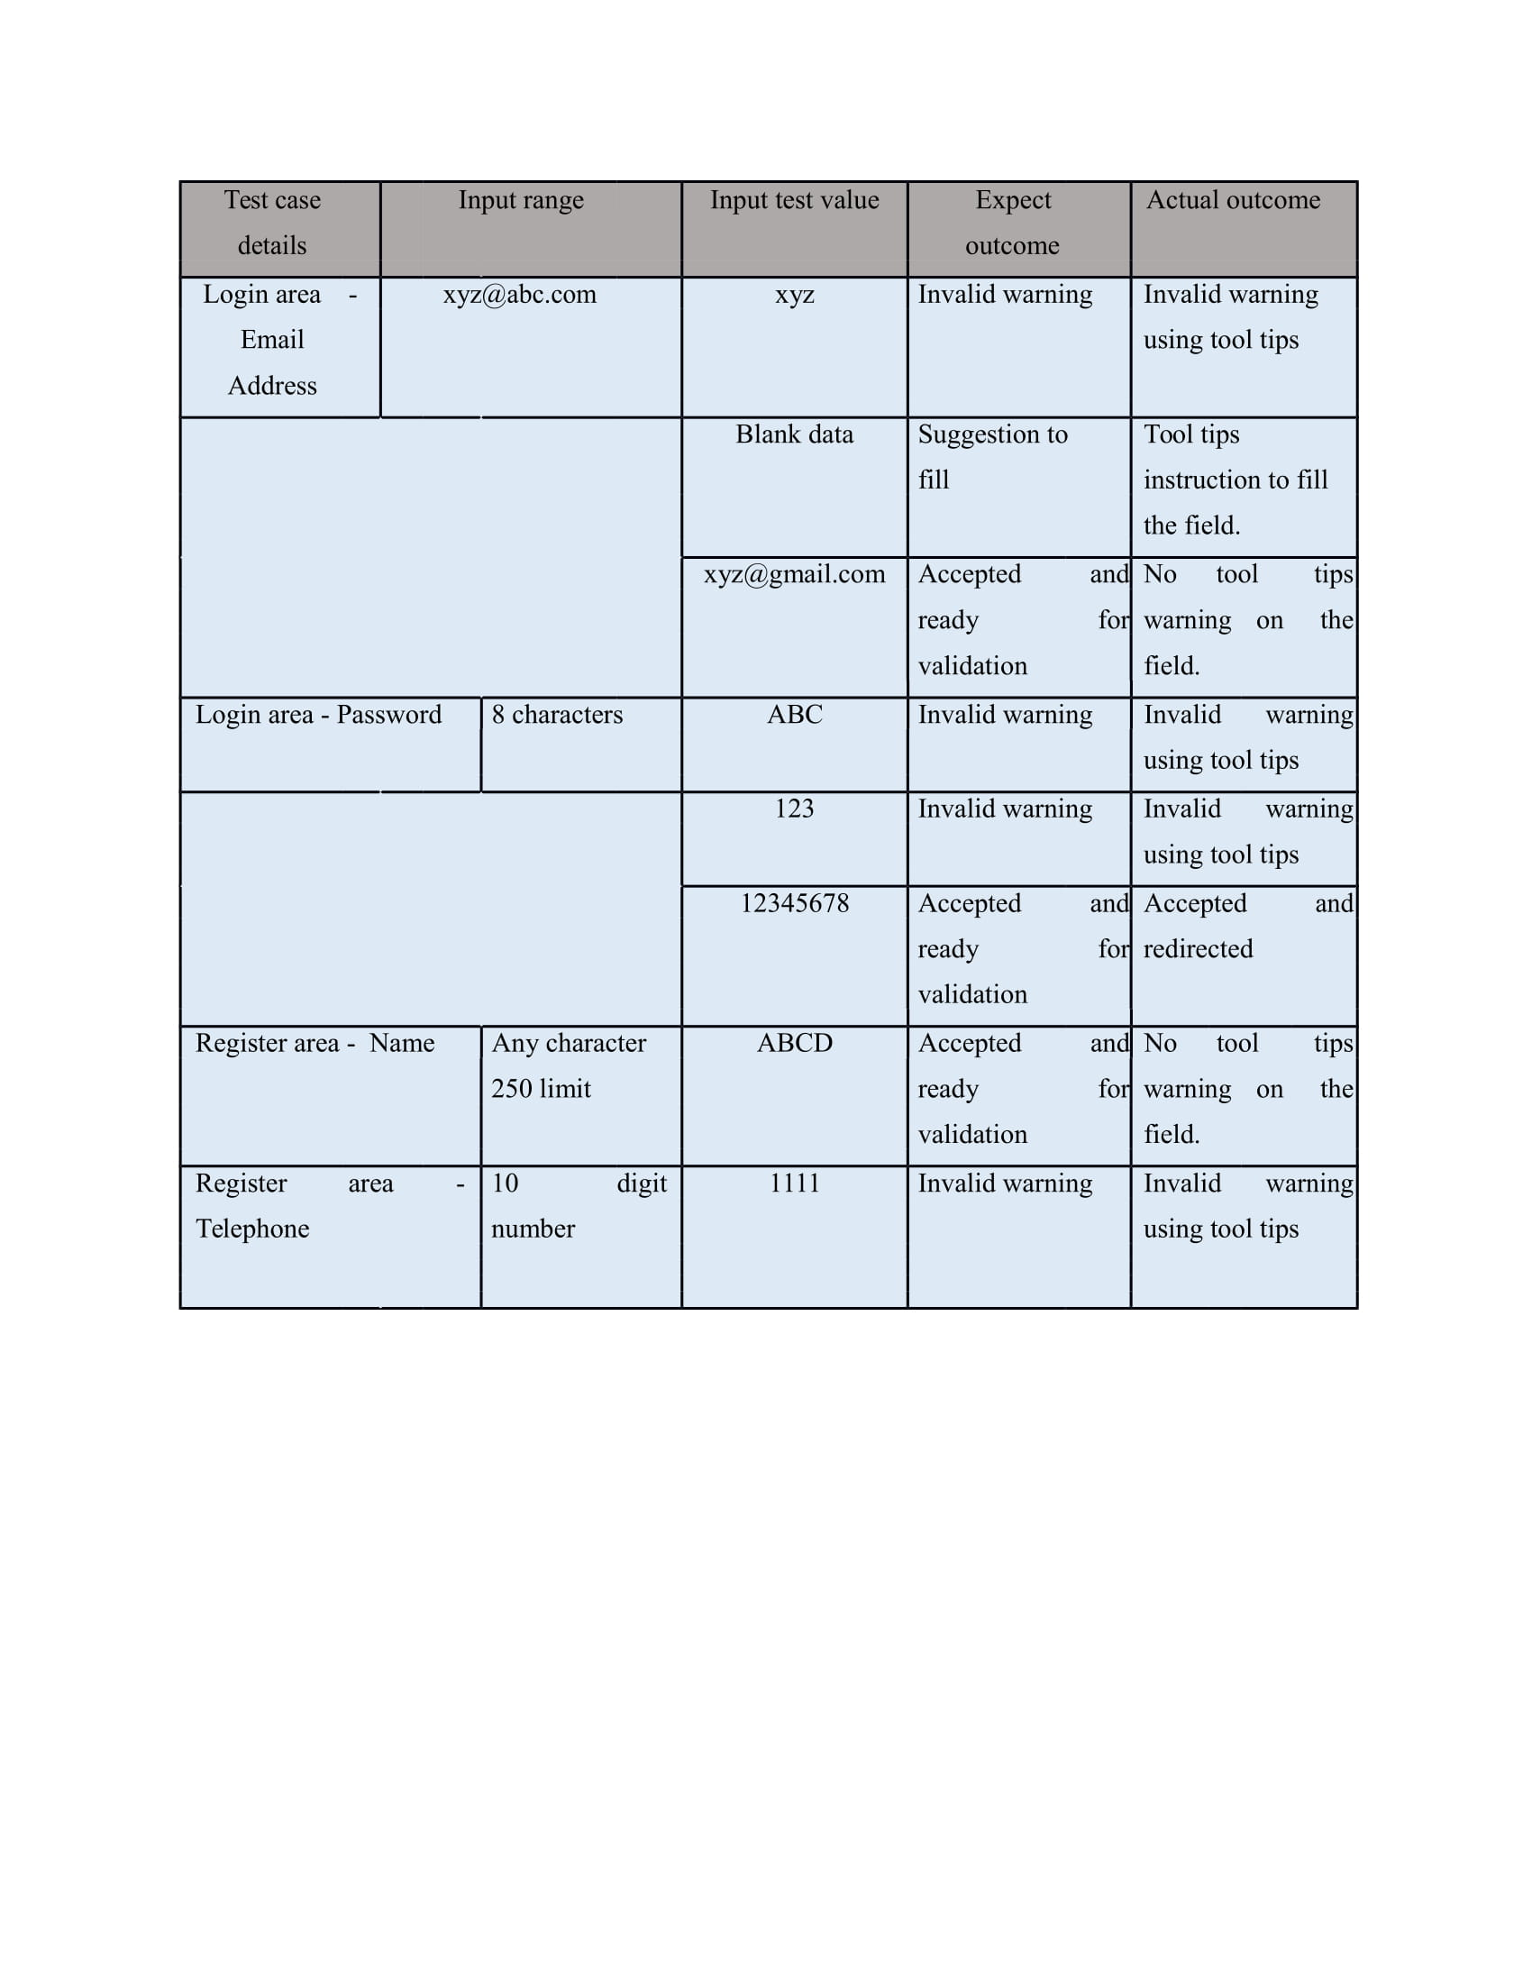**5.7.1 Range testing**

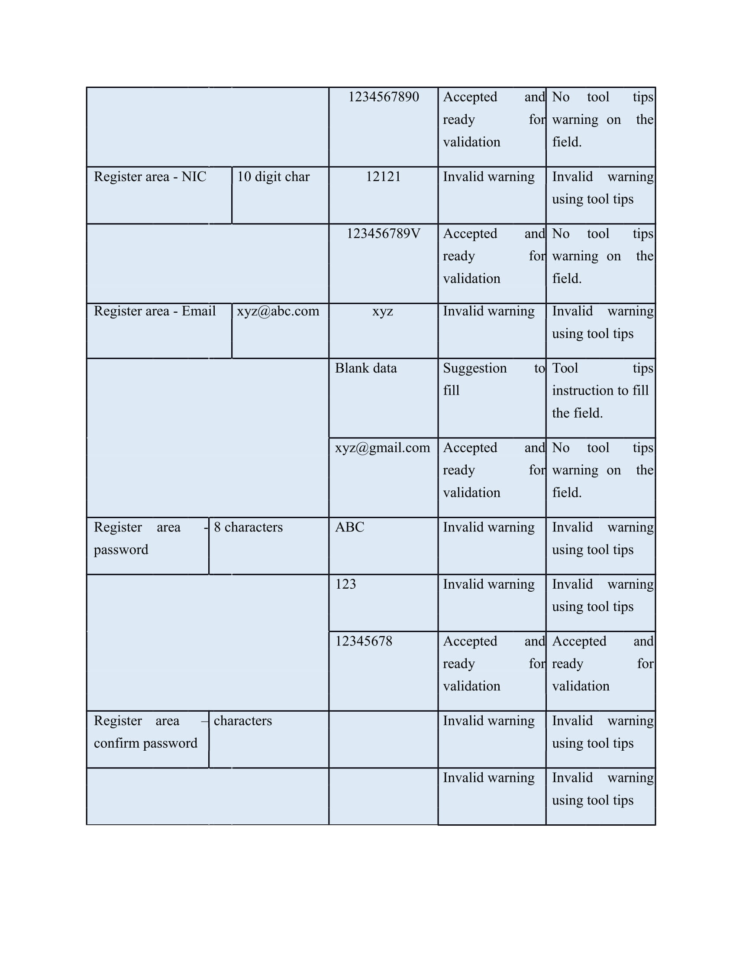

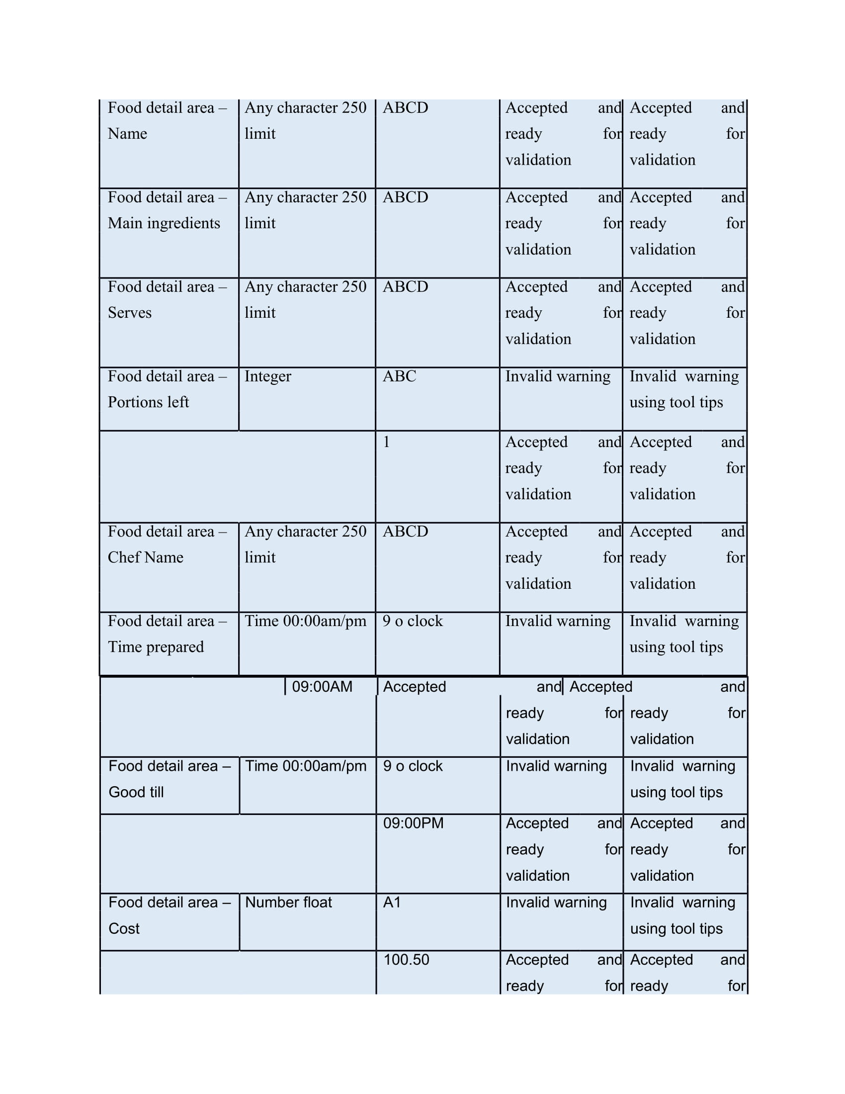

Table 5.1: Range testing

The above-mentioned inputs were tested based on the priorities, even though there were discrepancies, it was not on a big scale.

**5.7.2 Link testing**

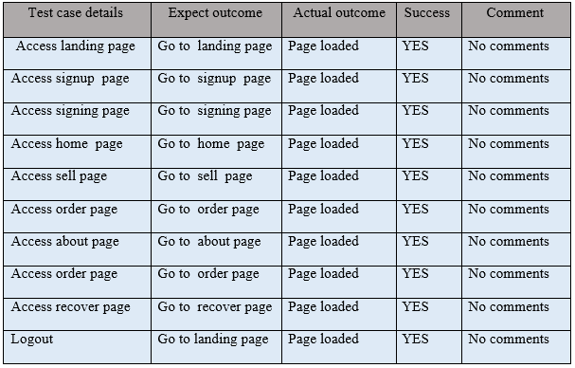

*Table 5.2: Link testing*

Test results of the application is passed successfully. And the link test is carried out the stability of the application.

## **5.8 Evaluation of the system**

The proposed system is designed and developed to solve all the problem statements which are stated in chapter one of this report. First of all, the developed system provides a feature that is able to solve the problem when the employee needs to have homemade foods and achieve the project objective of prevention of food serves not in sequence. By using the system, it allows employees to placed order homemade foods through using the system and the system will display the available homemade foods with the food details which prepared by the chefs. It also eliminates all the manual processes that involve in the traditional method of delivering foods. In addition, the developed system allows chefs to update all the food information as it is needed. This feature help to allow the customers to view the latest updated food menu information through using the system. By doing so, it helps chefs to solve the problem which regarding difficulties in updating menu card information, difficulties in providing appropriate updated food information and the potential of increase cost of operation as the system will automatically refresh all the updated information that is edited by the chef. Furthermore, the project objective which regarding provides convenience for the employees has been achieved because the system allow consumer to view all the updated information through the web application. In a nutshell, the system has fulfilled all significant outcomes that according to all the problem statements and project objectives that are stated.

**Increases the productivity:**

The homemade food ordering system saves consumers time by avoiding food orders over phone that has to be done manually. By making the ordering process fully automated, it increases the cost effectiveness and productivity with a less manpower.

In addition, it keeps one step ahead over the competitors who don’t serve online. This is the main reason for which the word online food ordering system is becoming more popular in these days.

**Saves the customers’ time:**

Nowadays as people are getting busy with their work. It allows them to order homemade food online from anywhere at any time by creating a flexible food ordering platform. This makes customers more comfortable.

Customers can select the homemade food items from the online and can order accordingly as per their interest. In fact, they can place the homemade food orders with in their budget by adding or removing the food items as per the cost variation.

**Efficient customer and order management**

* An online ordering system for homemade foods help to enhance the customer-restaurant relationship. To create a marketplace where both customer and services providers can communicate their needs without going through inconvenient processes.

## **5.9 Summery**

What the researcher has been doing here is mapping all the identified data into technical maps which will finally be taken into the implementation. All the identified data entities and the real-world objects are mapped and connected in this chapter. All of these conclusions were drawn up in reference with the data analyzed in Chapter 2.

Further, system will make the life easier for all the employees and can access easily. This will help a lot for the employees to order homemade foods which is available nearby area. System will be getting a notification when buyer will order a food. That notification directly goes to the particular seller. After that seller will deliver the foods to the particular customer. So, buyer can provide feedbacks and rating through the system.

So, this application is useful for the employees especially the people who are boarded in Colombo city. Women who are doing jobs, they do not have enough time for cooking. So, they can also use this application. This is very user friendly and anyone can access this application easily.

**CHAPTER SIX – CONCLUSIONS AND RECOMMENDATION**

**6.1 Introduction**

This chapter is the last chapter of the research. This chapter researcher will discuss about the suggestions for the research work. The research was finding a solution for employees who are seeking homemade foods. So, the research question was how to overcome the problems that has identified by the researcher. Therefore, researcher has proposed a solution for the identified problems. Having a web based application can solve this problem. Therefore, researcher has developed a web based application to overcome this problem.

* To examine the relationship between Convenience on Consumer Food Preference

Consumers are seeking more convenient food products to in order to save their cooking time. The current research has focused on drives of Convenience and how it has impacted to the consumer food preference. This research has proven that overall involvement with Convenience has a positive relationship on consumer food preference. And also, literature has suggested that there is a high impact between Conveniences on Consumer Food Preference. However, it is moderate in Sri Lankan perspective. Sometimes this is happening because of Sri Lankan people are still seeking fast foods for their convenience. Consumers often looking for convenient foods because of their lack of time.

Consumers are seeking more convenient food products to in order to save their cooking time. Supermarkets are providing pre-cut vegetables and pre-cooked foods to the customers. Therefore, foods like fast foods or ready-made products are becoming more popular than homemade foods. Most of the groceries become like one- stop shopping location where customers can buy any food whatever they want. In some studies, have analyzed that these types of convenient foods such as washed, packed, pre-cut vegetables and pre-cooked foods have less healthful diets and creating obesity and serious health issues such as cancer, diabetic, heart attacks where even doctors cannot find. However, these types of foods do not include nutrition ingredients than homemade foods.

The research data has suggested that consumers are more likely to have convenient foods when they are deciding their food preferences. And these data has proven that consumers are seeking the convenient food products because of they want to save their cooking time. Especially women do not have enough time for cooking because of their busy schedule.

In conclusion, if consumers are only looking for convenient food products and choosing fast foods, it will be huge impact to their life and they will get sick more quickly. Consumers need to have homemade foods for their life and they need to focus on their future. This research has established that the critical areas to address are consumer perceptions of food preferences and convenience food products in the Sri Lankan perspective.

* To examine the relationship between Availability on Consumer food preference.

According to the table 4.21 Correlation between these two variables are 0.534 at a 0.01 significant level. That means the researcher has identified that there is a positive relationship between those two variables called availability and food preference.

The factor “Availability” means actual availability of the purchasing foods in the nearby area. This means that consumers get a high score for this factor and do not want to walk longer to buy healthy foods. So, consumers with this factor, the offer is based on what is offered in shops near their homes or working places. The availability of homemade foods is very less than the availability of fast foods. This leads to change the consumption pattern of foods. The availability of homemade foods is very limited in Sri Lanka.

Some studies have examined that the food context can broaden or limit food choices specific factors of environmental food supply such as food types, food sources and availability of food in groceries. As a result of big stores like supermarkets, they are like to store healthier foods when it compared to small stores. Consumers escalate the capability of buying foods in their stores therefore, the environment be contingent on the availability of healthy foods in stores. However, less availability of healthy food in nearby stores is contributing to become more obese and it affect to the human life style. Previous literature mentioned that the availability of healthy meals in nearby areas is impacted to improve the health of human life.

The research data has suggested that consumers are more likely to have homemade foods when they are deciding their food preferences. And these data have proven that consumers are seeking the home-made food products because they are more concern about their life and they are expecting long living life.

In conclusion, if consumers are eating only homemade food products, it will be huge impact to their life and they can live more. Especially they can prevent of illnesses such as cancers, heart attacks, strokes, diabetics and etc. In this research has established that the critical areas to address are consumer perceptions of food preferences and homemade food products in Sri Lankan perspective.

* To examine the relationship between Natural content on Consumer food preference.

According to the table 4.25 Correlation between these two variables are 0.530 at a 0.01 significant level. That means the researcher has identified that there is a positive relationship between those two variables called Natural content and food preference.

Foods which is included natural ingredients means not including artificial ingredients. People like to eat non- artificial ingredients foods which means they like to eat foods that is only included natural ingredients. Natural ingredients foods are always good for the health. There are less availability foods in shops which is included only natural ingredients. So, it is very difficult to find natural ingredients foods in a country like Sri Lanka.

In past decades consumers have increased their interest of foods which is included natural ingredients and packaging that they take decisions of food choices. Foods which is included natural ingredients means not including artificial ingredients. Steptoe and Pollard has found that the connection between age and natural content that means, the more the customer, the more important this product. According to prior research has shown that employees are demanding for healthy meals which include fresh ingredients and healthful ingredients. Also, the natural content has associated with the healthiest life. People who are seeking only natural ingredients foods are benefited to their body, skin, hair etc. As researcher mentioned earlier that employees are demanding more healthful products and the natural content foods.

The research data has suggested that consumers are more likely to have natural ingredients foods than having artificial ingredients foods when they are deciding their food preferences. And these data have proven that consumers are seeking the natural ingredients food products because they are more concern about their life and they are expecting long living life.

In conclusion, if consumers are eating only natural ingredients food products, it will be huge impact to their life and they can live more. However, in Sri Lanka it is less available for the natural content foods. So, people who are doing jobs, they like to have natural content foods. According to the research data, researcher has identified there is positive relationship between natural content on consumer food preference. In this research has established that the critical areas to address are consumer perceptions of food preferences and natural content food products in Sri Lankan perspective.

* To examine the relationship between Weight benefits on Consumer food preference.

According to the table 4.29 Correlation between these two variables are 0.520 at a 0.01 significant level. That means researcher has identified that there is positive relationship between those two variables called Weight benefits and food preference.

Nowadays most of the people are considering about their weight. To maintain the weight, people need to control the foods when they are making the decisions of food choices. In current situation maintaining the weight is not easy. Overweight is leading to the obesity. When someone is in obesity it is leading to create some serious health issues.

The researcher has found that employees have poor eating behavior which means they have less nutrition foods and that is leading to became overweight and obesity. Marcia Greenblumm said that employees know the importance of eating the healthy foods but they have told that they are not eating healthy foods always as they need. They are having foods whenever they need but they do not make about food decisions whether it is benefited or not. When people think about weight benefits such as what to eat and what not to eat, they choose the foods which is having low fat that is contributing to control their weight. According to the prior study among employees have examined that what they are doing is to control their weight. According to the result of this study has shown that 73 per cent of people have involved to control their weight.

The research data has suggested that consumers are considering about their health when they are deciding their food preferences. And these research data have proven that consumers are more likely to have home foods because they knew the benefits of having homemade foods.

In conclusion, if consumers are considering about their weight, it will be huge impact to their life and they can live more. According to the research data, researcher has identified there is positive relationship between weight benefit on consumer food preference. In this research has established that the critical areas to address are consumer perceptions of food preferences and natural content food products in Sri Lankan perspective.

* To examine the relationship between Sensory appeal on Consumer food preference.

According to the table 4.33 Correlation between these two variables are 0. 540 at a 0.01 significant level. That means researcher has identified that there is positive relationship between those two variables called Sensory appeal and food preference.

Sensory appeal is including appearance, smell and taste. So, appearance, smell and taste of foods are very important when people choose the foods and thinking what to eat. However, this does not lead to have healthy meals, but this is useful for the people when they are choosing the healthy products. Tasty is the main element in when people are choosing foods. Consumer’s first impression is testing the foods with tasty, smell and appearance.

Prior research has shown that having good taste is very useful for the consumption pattern of healthy products. Based on the results of the study of employees have found that their consumption pattern of foods is based on hunger and food thirsts, food appeal, time considerations and convenience of foods. Also, the study has shown that employees are said like they would like to eat healthy foods if foods are tastiest and have freshness. Based on these studies sensory appeal is most important when choosing foods.

The research data has suggested that consumers are considering about appearance, smell and taste when they are deciding their food preferences. And these research data have proven that consumers are good tasty is leading to choose the types of foods.

In conclusion, if consumers are considering about their Sensory appeal, it will be huge impact to their life. According to the research data, researcher has identified there is positive relationship between Sensory appeal on consumer food preference. In this research has established that the critical areas to address are consumer perceptions of food preferences and Sensory appeal food products in Sri Lankan perspective.

* To examine the relationship between Price on Consumer food preference.

According to the table 4.37 Correlation between these two variables are 0. 510 at a 0.01 significant level. That means researcher has identified that there is positive relationship between those two variables called Price and food preference.

For most of the customers price and time are the wall when making the decisions about food choices. Healthy foods are more expensive because those foods are helping to improve the health of human life. Price reduction strategy is impacted to the healthy food choices. Also, big stores food products are cheaper than small stores food products and this leads to gain the weight.

Price is very important when choosing foods but an increase of price leads to involve the poor eating behavior. Therefore, the consumer’s level of income is affected to the selection of foods. According to Anker study has shown that most employees are moved to the capital city to do jobs. However, their income is not enough to buy healthy products. Therefore, they have poor eating habits. The main barrier of healthy eating is the cost. They do not have a higher income to buy home-made foods. So, this verifies that there is more demand for healthy foods, but healthy foods are very expensive than unhealthy products. So, the price of factor, it basically measures how important it is for buyers to buy cheap foods which have higher density products.

The research data has suggested that consumers are considering about price when they are deciding their food preferences. And these research data have proven that the price is main barrier to choosing homemade foods. Because homemade foods price is higher than fast foods price.

In conclusion, if consumers are considering about their Sensory appeal, it will be huge impact to their life. According to the research data, researcher has identified there is positive relationship between Sensory appeal on consumer food preference. In this research has established that the critical areas to address are consumer perceptions of food preferences and Sensory appeal food products in Sri Lankan perspective.

* To examine the relationship between Health concern on Consumer food preference.

According to the table 4.41 Correlation between these two variables are 0. 530 at a 0.01 significant level. That means the researcher has identified that there is a positive relationship between those two variables called Price and food preference.

Employees have positive attitudes of having healthy products. Functional foods are like healthful products which is added or removed unhealthy ingredients to improve the healthiness of the products. Consumers are considering about health when they are choosing the foods. Because the researchers have found that serious health issues are creating from foods. So, eating healthy foods can prevent of creating serious health issues such as heart attacks, strokes, cancers, diabetics and etc.

People like to eat more foods that which contain sugar instead of non-added sugar foods such as yogurt and etc. Health concern means the importance health condition of the human body such as how to improve skin, teeth, hair and nails with the help of healthful products. Previous research has shown that appearance contributes to healthy food choices. Some researchers have mentioned that people have health behavior because they are considering about their appearance. So, the healthful foods are contributing to improving the attractive body and healthful skin. According to the Shackelford and Larson study has claimed that there is a relationship between physical health and these foods.

The research data has suggested that consumers are considering about health when they are deciding their food preferences. And these research data have proven that the health is the main factors which leads to have consumers’ long life.

In conclusion, if consumers are considering about their health, it will be huge impact to their life and they can live a long life. According to the research data, researcher has identified there is positive relationship between health concern on consumer food preference. In this research has established that the critical areas to address are consumer perceptions of food preferences and health concern food products in Sri Lankan perspective.

* To examine the relationship between Organic concern on Consumer food preference.

According to the table 4.45 Correlation between these two variables are 0. 560 at a 0.01 significant level. That means researcher has identified that there is positive relationship between those two variables called Organic concern and food preference.

Nowadays there is a huge demand for organic foods. Consumers are choosing only products which have benefited to them when they make decisions of what to eat. Organic foods price is higher than fast foods price. However, in Sri Lanka there is less availability of organic foods. That is why organic foods price is high.

According to the prior study has found that people like to have organic foods because they are considering about their health. Rianto Heru study has shown that organic foods do not contain artificial ingredients and it only contained the originality of the product. Today’s society is more concerned about food safety. Basha Bilal research has mentioned that consumers’ food eating behavior can be changed based on their situation. Organic foods help to improve the health and bringing benefits. Most people are choosing organics foods when they are doing shopping and it is helpful their body and also the environment.

The research data has suggested that consumers are considering about organic foods when they are deciding their food preferences. And these research data have proven that the organic foods are benefited to the healthy life.

In conclusion, if consumers are considering about organic foods, it will be huge impact to their life and they can live a long life. According to the research data, researcher has identified there is a positive relationship between Organic concern on consumer food preference. In this research has established that the critical areas to address the consumer perceptions of food preferences and organic concern food products in Sri Lankan perspective.

## **6.2 Recommendations**

The employees suggested that physical appearance could be a motivator to lose some weight and therefore it might be better in future research to divide the factor health concern into two separate constructs, concern for appearance and concern for health. Whereas concern for appearance is more focused on foods that are beneficial for skin, teeth, hair and body and concern for health is more focused on the motivation to choose foods that are good for health and organs and the prevention of diseases.

Second, the construct of subjective norm that was introduced for the first time related to food choice motives consisted of items that were in general related to the influence of others. However, this caused some difficulties in interpreting the results since it was not clear if subjective norm was either good or bad regarding healthy food choices. Therefore, the author’s advice for future research is to add new items to this construct that says, for instance, that it is important for the subject that his friends or relatives make healthy food choices so that it supports the subject to do the same. Because consumer’s dietary choices tend to converge with their close social connections and interesting to know is if these social norms contribute to healthier food choices.

Third, The Cronbach´s alphas for two of the twelve constructs were far below acceptable level but were, however, included in the study. The fact that the constructs consists of only two items may have caused the low internal consistency, because it is claimed based on the formula that the more items are added to a construct the higher the Cronbach´s alpha will be. The author did not delete the constructs from the study because they have both been used in prior research and the items were selected through factor analysis. Translation could also be the reason for the low alpha score of the construct ‘availability’, but this construct with the same items included has also been used in prior research. Future research should take a critical look at the constructs for food choices and see whether the internal consistency could be improved. Finally, employees in the present study were mostly approached through social media and one fourth was reached via a market response agency.

Moreover, it is better to do further research on factors that affect to food preference of employees in Sri Lanka and also this web application was focused only the people in Colombo area. It is better to develop this system to use every city in Sri Lanka. So, everyone can use this system according to their food preference.

The system can implement a feature which is real time notification from the mobile phone application to the service desk. This feature enable customer to request customer service through using the mobile application. In addition, the mobile application also can implement a feature that allow customer to update the food serve status. For example, customers fine dining, they can request the food to be serve through using the mobile application and if the customer finish the main course and feeling full, the customer may request do not serve the following food through using the mobile application.

## **6.3 Limitations and Constraints**

The study was focused on eight dimensions of food preference only. Other than that lot of other dimensions may affect to the food preference. However here the researcher didn’t discuss about those other factors. The developed web application can use only people who are living Colombo city.

## **6.4 Solution**

The proposed solution for the employees will help to have homemade foods according to their food preference from the home chefs and enhance the customer satisfaction. After the system developed now it is easy to order homemade foods which prepared from home chefs. So, time saving is a major advantage.

## **6.5 Further work**

Conclude the document by briefly describing how the developed solution can be improved further.  
The researcher also found from different reviews that was someone else's have been discuss a system like this and which features that was not in the system are. Researcher would to develop mobile app features to log on to the system for anyone who wants to order homemade foods according to their food preference.

**7. REFERENCES**

[1]2019. [Online]. Available: https://www.researchgate.net/publication/277076342_Consumers'_preference_and_consumption_towards_fast_food_Evidence_from_Malaysia. [Accessed: 15- Dec- 2019].

[2]Zenithresearch.org.in, 2019. [Online]. Available: http://zenithresearch.org.in/images/stories/pdf/2012/JUNE/ZIJMR/12_ZIJMR_VOL2_ISSUE6_JUNE2012.pdf. [Accessed: 16- Dec- 2019].

[3]J. Shepherd, "Young people and healthy eating: a systematic review of research on barriers and facilitators", 2019.

[4]"Organic food as a healthy lifestyle: A phenomenological psychological analysis", *Taylor & Francis*, 2019. [Online]. Available: https://www.tandfonline.com/doi/full/10.3402/qhw.v8i0.20559. [Accessed: 16- Dec- 2019].

[5]*Essay.utwente.nl*, 2019. [Online]. Available: http://essay.utwente.nl/72589/1/Mackenbrock_MA_Behavioral%2C%20Management%20and%20Social%20Sciences.pdf. [Accessed: 16- Dec- 2019].

[6]*Scet.berkeley.edu*, 2019. [Online]. Available: http://scet.berkeley.edu/wpcontent/uploads/UCookWhitePaper.pdf. [Accessed: 16- Dec- 2019].

[7] Mueller, S.; Szolnoki, G. The relative influence of packaging, labelling, branding and sensory attributes on liking and purchase intent: Consumers differ in their responsiveness. *Food Qual. Prefer.* 2010, *21*, 774–783. [Google Scholar] [CrossRef].

[8] Menichelli, E.; Olsen, N.V.; Meyer, C.; Næs, T. Combining extrinsic and intrinsic information in consumer acceptance studies. *Food Qual. Prefer.* 2012, *23*, 148–159. [Google Scholar] [CrossRef].

[9] Combris, P.; Bazoche, P.; Giraud-Héraud, E.; Issanchou, S. Food choices: What do we learn from combining sensory and economic experiments? *Food Qual. Prefer.* 2009, *20*, 550–557. [Google Scholar] [CrossRef].

[10] Olsen, N.V.; Menichelli, E.; Meyer, C.; Næs, T. Consumers liking of private labels. An evaluation of intrinsic and extrinsic orange juice cues. *Appetite* 2011, *56*, 770–777. [Google Scholar] [CrossRef].

[11] Wansink, B.; Payne, C.R.; North, J. Fine as North Dakota wine: Sensory expectations and the intake of companion foods. *Physiol. Behav.* 2007, *90*, 712–716. [Google Scholar] [CrossRef].

[12] Sörqvist, P.; Marsh, J.E.; Holmgren, M.; Hulme, R.; Haga, A.; Seager, P.B. Effects of labeling a product eco-friendly and genetically modified: A cross-cultural comparison for estimates of taste, willingness to pay and health consequences. *Food Qual. Prefer.* 2016, *50*, 65–70. [Google Scholar] [CrossRef].

[13] Bartels, M.; Tillack, K.; Jordan Lin, C.-T. Communicating nutrition information at the point of purchase: An eye-tracking study of shoppers at two grocery stores in the United States. *Int. J. Consum. Stud.* 2018, *42*, 557–565. [Google Scholar] [CrossRef].

[14] Orquin, J.L.; Bagger, M.P.; Lahm, E.S.; Grunert, K.G.; Scholderer, J. The visual ecology of product packaging and its effects on consumer attention. *J. Bus. Res.* 2019. [Google Scholar] [CrossRef].

[15] Graham, D.J.; Orquin, J.L.; Visschers, V.H.M. Eye tracking and nutrition label use: A review of the literature and recommendations for label enhancement. *Food Policy* 2012, *37*, 378–382. [Google Scholar] [CrossRef].

[16] Fenko, A.; Nicolaas, I.; Galetzka, M. Does attention to health labels predict a healthy food choice? An eye-tracking study. *Food Qual. Prefer.* 2018, *69*, 57–65. [Google Scholar] [CrossRef].

[17] Oliveira, D.; Machín, L.; Deliza, R.; Rosenthal, A.; Walter, E.H.; Giménez, A.; Ares, G. Consumers’ attention to functional food labels: Insights from eye-tracking and change detection in a case study with probiotic milk. *LWT-Food Sci. Technol.* 2016, *68*, 160–167**.** [Google Scholar] [CrossRef].

[18] Gere, A.; Danner, L.; de Antoni, N.; Kovács, S.; Dürrschmid, K.; Sipos, L. Visual attention accompanying food decision process: An alternative approach to choose the best models. *Food Qual. Prefer.* 2016, *51*, 1–7. [Google Scholar] [CrossRef].

[19] Rebollar, R.; Lidón, I.; Martín, J.; Puebla, M. The identification of viewing patterns of chocolate snack packages using eye-tracking techniques. *Food Qual. Prefer.* 2015, *39*, 251–258**.** [GoogleScholar] [CrossRef]

[20] "Organic food as a healthy lifestyle: A phenomenological psychological analysis", *Taylor & Francis*, 2019. [Online]. Available: https://www.tandfonline.com/doi/full/10.3402/qhw.v8i0.20559. [Accessed: 16- Dec- 2019].

[21] "Global social media research summary 2019 | Smart Insights", *Smart Insights*, 2019. [Online]. Available: https://www.smartinsights.com/social-media-marketing/social-media-strategy/new-global-social-media-research/. [Accessed: 27- Dec- 2019].

[22] "Deductive Approach (Deductive Reasoning) - Research-Methodology", *Research-Methodology*, 2019. [Online]. Available: https://research-methodology.net/research-methodology/research-approach/deductive-approach-2/#_ftnref1. [Accessed: 27- Dec- 2019].

# **APPENDIX**

## **Questionnaires**

**Impact of homemade food for employees- A SriLankan Perspective**

Please mark a tick (√) for the appropriate cage which describes your involvement with the food preference (Fast foods and Homemade foods) (Five- point scales, ranging from Strongly Disagree to Strongly Agree.)

1 = Strongly Disagree

2 = Disagree

3 = Neither Disagree nor Agree

4 = Agree

5 = Strongly Agree

**Section 1: Convenience**

|  |  |  |  |  |  |  |
| --- | --- | --- | --- | --- | --- | --- |
|  |  | 1 | 2 | 3 | 4 | 5 |
| C1 | I always consider about convenience of the foods |  |  |  |  |  |
| C2 | I don’t have time for cooking. But I always like home made foods |  |  |  |  |  |
| C3 | There is no safety to eat ready-made foods |  |  |  |  |  |
| C4 | I think that fast foods are more convenience than homemade foods |  |  |  |  |  |

**Section 2: Availability**

|  |  |  |  |  |  |  |
| --- | --- | --- | --- | --- | --- | --- |
|  |  | 1 | 2 | 3 | 4 | 5 |
| A1 | I can easily choose any fast foods when it is available |  |  |  |  |  |
| A2 | I can order fast foods anytime than homemade foods |  |  |  |  |  |
| A3 | It is difficulty find homemade foods because it’s not available when I need. |  |  |  |  |  |
| A4 | When I order junk foods, they deliver as soon as possible. |  |  |  |  |  |

**Section 3: Natural content**

|  |  |  |  |  |  |  |
| --- | --- | --- | --- | --- | --- | --- |
|  |  | 1 | 2 | 3 | 4 | 5 |
| NC1 | I concern about use of natural ingredients of the foods to take the foods decisions. |  |  |  |  |  |
| NC2 | I only concern about the natural content because it’s impact to my healthier lifestyle. |  |  |  |  |  |
| NC3 | I like to eat foods which content natural ingredients. |  |  |  |  |  |
| NC4 | Artificial ingredients foods create health issues to the people |  |  |  |  |  |

**Section 4: Weight benefits**

|  |  |  |  |  |  |  |
| --- | --- | --- | --- | --- | --- | --- |
|  |  | 1 | 2 | 3 | 4 | 5 |
| WB1 | I always like to eat low fat foods because it impacts to the heart issues. |  |  |  |  |  |
| WB2 | Homemade foods are the healthier foods which is affects to the long living life. |  |  |  |  |  |
| WB3 | I concern about my body weight. So, I prefer to eat healthier foods. |  |  |  |  |  |
| WB4 | I know that I am over weighted because of my unhealthy food pattern. |  |  |  |  |  |

**Section 5: Sensory appeal**

|  |  |  |  |  |  |  |
| --- | --- | --- | --- | --- | --- | --- |
|  |  | 1 | 2 | 3 | 4 | 5 |
| SA1 | I am considering about the appearance, smell and taste when choosing the foods. |  |  |  |  |  |
| SA2 | I would like to eat healthful foods if the foods are taste and look better. |  |  |  |  |  |
| SA3 | I am eating any foods (fast foods or homemade foods) if it is very tasty. |  |  |  |  |  |
| SA4 | I think that good taste is necessary thing for the consumption of fruit and vegetables. |  |  |  |  |  |

**Section 6: Price**

|  |  |  |  |  |  |  |
| --- | --- | --- | --- | --- | --- | --- |
|  |  | 1 | 2 | 3 | 4 | 5 |
| P1 | When making decisions of healthy food choices, price is a major barrier for me. |  |  |  |  |  |
| P2 | My income is not enough to buy healthy foods. |  |  |  |  |  |
| P3 | I prefer to buy cheaper foods from the food outlets. |  |  |  |  |  |
| P4 | I know that lower price foods are offering less quality and it is not good to our body. |  |  |  |  |  |

**Section 7: Health Concern**

|  |  |  |  |  |  |  |
| --- | --- | --- | --- | --- | --- | --- |
|  |  | 1 | 2 | 3 | 4 | 5 |
| HC1 | I like to eat sugary foods instead of non – sugary foods like yogurts. |  |  |  |  |  |
| HC2 | Healthy foods are beneficial for skin, teeth, hair and nails and also increase the attractiveness. |  |  |  |  |  |
| HC3 | Eating healthy foods prevent chronic disease. |  |  |  |  |  |
| HC4 | I am always considering about my health. So, I avoid eating unhealthy foods. |  |  |  |  |  |

**Section 8: Organic concern**

|  |  |  |  |  |  |  |
| --- | --- | --- | --- | --- | --- | --- |
|  |  | 1 | 2 | 3 | 4 | 5 |
| OC1 | I would like to eat organic foods because it is beneficial to my body. |  |  |  |  |  |
| OC2 | When I do shopping I prefer to go the section which is having organic foods. |  |  |  |  |  |
| OC3 | My food eating behavior is changing based on the situation. |  |  |  |  |  |
| OC4 | I always reflect about the safety of foods. |  |  |  |  |  |

**Section 9: Food Preference**

|  |  |  |  |  |  |  |
| --- | --- | --- | --- | --- | --- | --- |
|  |  | 1 | 2 | 3 | 4 | 5 |
| FP1 | I like only Homemade foods. |  |  |  |  |  |
| FP2 | I like only Fast foods. |  |  |  |  |  |
| FP3 | I like both Homemade and fast foods. |  |  |  |  |  |
| FP4 | Lack of time is the main reason for choosing fast foods. |  |  |  |  |  |
| FP5 | I prefer if I can order prepared foods online that are available within my city. |  |  |  |  |  |

**Section 10: Demographic Factors**

Please tick (√) the appropriate cage representing the most appropriate responses for you in respect of the following items

1. Gender:

|  |  |  |  |  |  |
| --- | --- | --- | --- | --- | --- |
| 1. | Male |  | 2. | Female |  |

1. Age category you belong to:

|  |  |  |
| --- | --- | --- |
| 1 | 18 -24 yrs |  |
| 2 | 25 -34 yrs |  |
| 3 | 35 and above |  |

1. Please state your occupational category

|  |  |  |
| --- | --- | --- |
| 1 | Employeed |  |
| 2 | Self Employeed |  |

**Thank you for your kind cooperation**

## **Screen Designs of the Application**

### **Sign up page for Seller**



This is seller registering page. Seller can register to the system by providing name, e-mail address, NIC, Phone number, seller description and creating a new password.

### **Login page for Seller**

This is seller login page. Seller can login to the system by providing valid credentials.

### **Seller Home page**

This is seller home page. In this page, it contains food details, order details, user details and admin details.

### **Seller Food menu**

This is seller food details page. In this page it has food name, price, serves and how many portion has left

### **Seller – Add new food page**

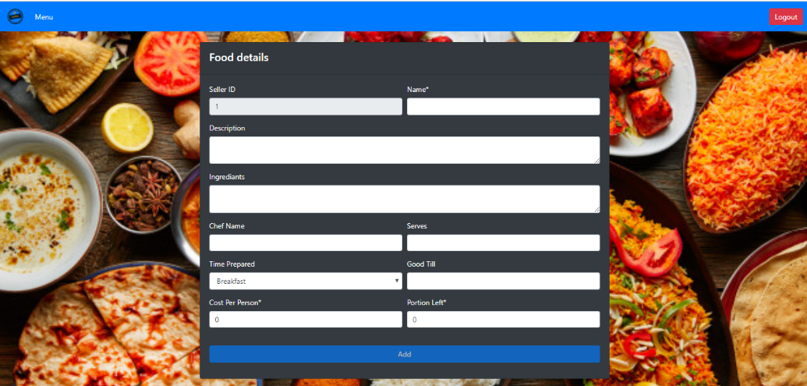

### **Seller – Edit Food Detail page**

### **Seller – Delete Food Page**

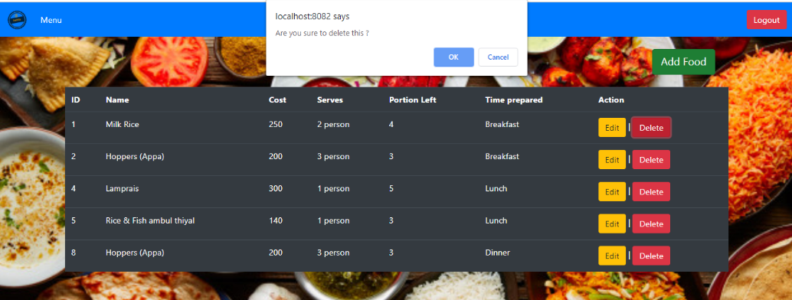

### **Buyer Sign up Page**



This buyer registering page. Buyer can register to the system by providing correct details such as name, e-mail address, NIC, phone number and create new password.

### **Buyer Login Page**



Buyer can login to the system by providing valid credentials.

### **Buyer Home page**

This is buyer home page. In this page it has food details, order details, buyer details and admin details.

### **Buyer Menu page**



This is buyer menu page. Buyer can see the available foods in the system. By clicking Buy now button buyer can order the food according to his/ her food preference.

### **Buyer Food details page**

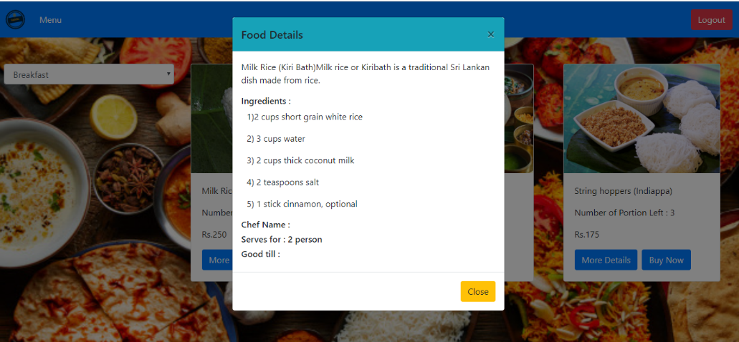

### **Buyer ordering a food page**

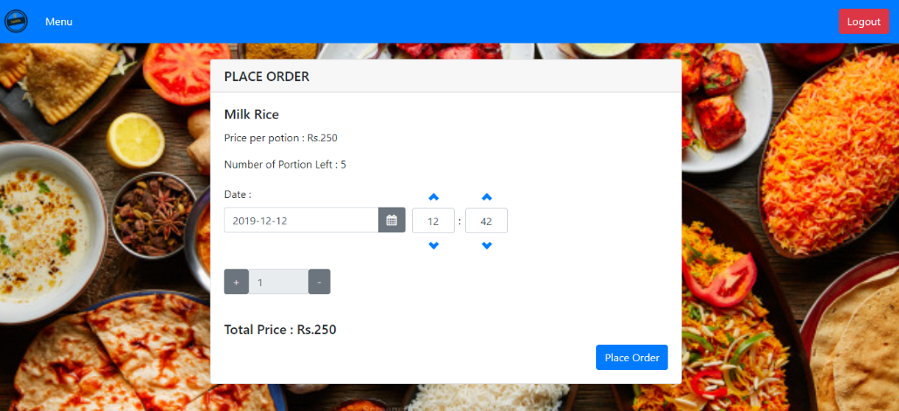

### **Buyer – Successful order page**

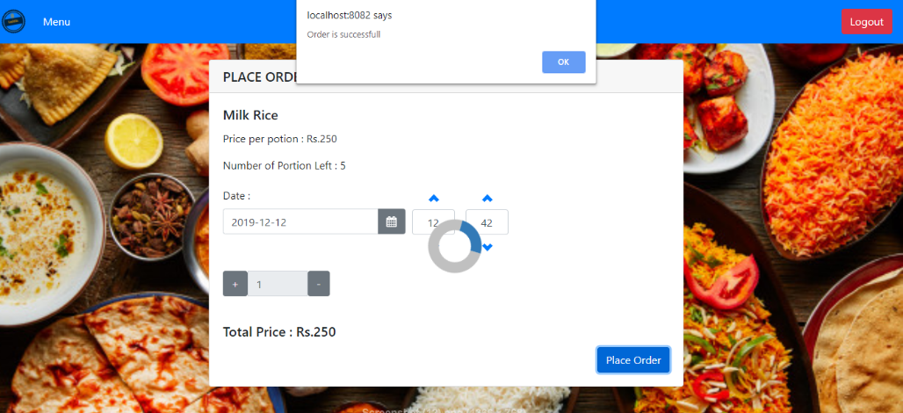

### **Buyer Order details page**

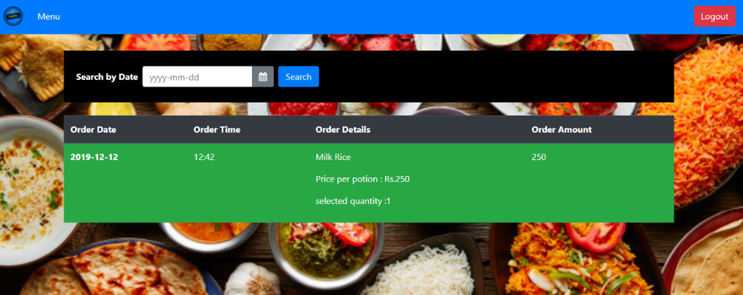

### **Buyer details page**

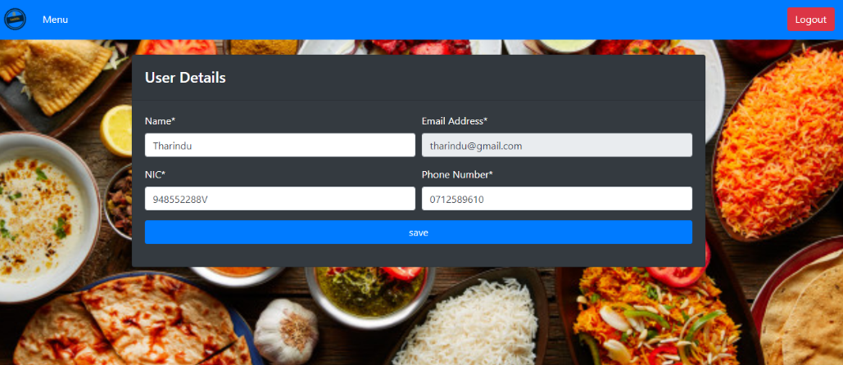

### **Application contact details page**

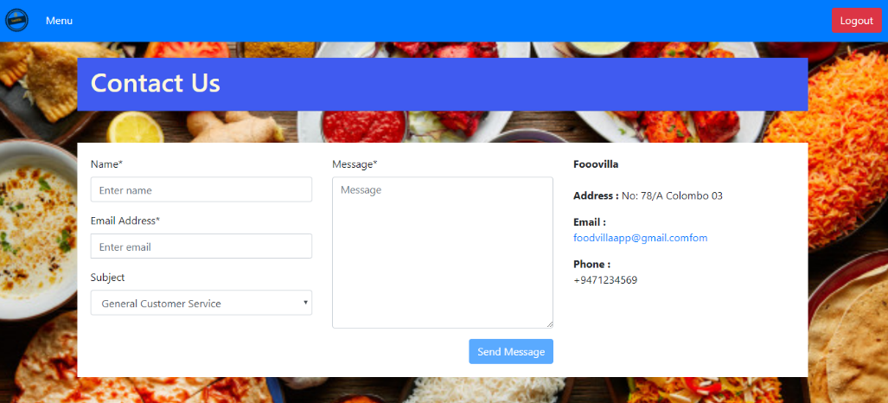

## **Summary of the collected data**

1. Convenience

|  |  |
| --- | --- |
| **Data Collection Method** | **Percentage** |
| Agree | 10% |
| Strong Agree | 65% |
| Neutral | 5% |
| Disagree | 10% |
| Strong disagree | 10% |

1. Availability

|  |  |
| --- | --- |
| **Data Collection Method** | **Percentage** |
| Agree | 10% |
| Strong Agree | 15% |
| Neutral | 55% |
| Disagree | 10% |
| Strong disagree | 10% |

1. Natural Content

|  |  |
| --- | --- |
| **Data Collection Method** | **Percentage** |
| Agree | 50% |
| Strong Agree | 25% |
| Neutral | 15% |
| Disagree | 10% |
| Strong disagree | 0% |

1. Weight benefits

|  |  |
| --- | --- |
| **Data Collection Method** | **Percentage** |
| Agree | 5% |
| Strong Agree | 30% |
| Neutral | 60% |
| Disagree | 5% |
| Strong disagree | 0% |

1. Sensory appeal

|  |  |
| --- | --- |
| **Data Collection Method** | **Percentage** |
| Agree | 50% |
| Strong Agree | 25% |
| Neutral | 15% |
| Disagree | 5% |
| Strong disagree | 5% |

1. Price

|  |  |
| --- | --- |
| **Data Collection Method** | **Percentage** |
| Agree | 10% |
| Strong Agree | 65% |
| Neutral | 5% |
| Disagree | 10% |
| Strong disagree | 10% |

1. Health concern

|  |  |
| --- | --- |
| **Data Collection Method** | **Percentage** |
| Agree | 10% |
| Strong Agree | 15% |
| Neutral | 55% |
| Disagree | 10% |
| Strong disagree | 10% |

1. Organic Concern

|  |  |
| --- | --- |
| **Data Collection Method** | **Percentage** |
| Agree | 50% |
| Strong Agree | 25% |
| Neutral | 15% |
| Disagree | 10% |
| Strong disagree | 0% |